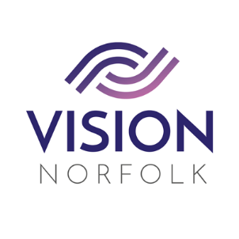

Role Title: | Community Outreach Volunteer
Hours and Location: | To be agreed upon completion of training
About the organisation: | Vision Norfolk’s mission is to support people living with sight loss to enjoy active, independent and fulfilled lives.
About the role: | We are looking for volunteers to support our Community Outreach Workers. The role may include the following:  - Supporting our clients to manage their homes independently by helping to label and organise items, such as CDs, clothing.  - Attend events to promote Vision Norfolk and the Community Outreach Service.  - Provide support to run and help out at coffee mornings around the county promoting our work and making direct connections with potential clients.  - Support our clients to feel confident attending activities and events
Skills / Experience needed: | - Our volunteers must be caring, able to communicate well and enjoy meeting new people, whilst helping our clients to remain as independent as possible.  - Experience of supporting people on a one to one basis would be advantageous but not essential  - Talk to / listen to our clients (if that’s what they want) and make them feel comfortable in your company.
Benefits of Volunteering in this role: | Becoming a volunteer is a wonderful opportunity to make a difference and support your local community. Vision Norfolk also offers:  - Visual Awareness Training  - Regular, ongoing advice and support from Vision Norfolk  - Payment of out of pocket expenses agreed in advance
Contact details: | To discuss this role or other opportunities please contact the Volunteer Engagement Coordinators on 01603 573000 or volunteers@visionnorfolk.org.uk. We also have application forms available on our website: www.visionnorfolk.org.uk

