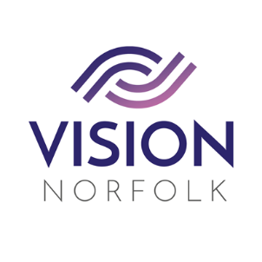

Role Title: | Children, Young People and Families (CYPF) Volunteer
Hours and Location: | To be agreed upon completion of training
About the organisation: | We are Vision Norfolk and our mission is to support people living with sight loss to live active, independent and fulfilled lives.
About the role: | In this role you will support vision impaired young people and their families during CYPF events, to enable them to enjoy the same activities as fully sighted children by promoting confidence and independence.  CYPF volunteers engage in a variety of activities, including running playgroups, zoo and museum trips, and more.  While volunteering you will be required to wear your photo identity badge during all assignments and wear a supplied CYPF t-shirt and/or hooded sweatshirt during events.  Due to the nature of the role we also require you to undertake extra safeguarding training, which will be provided as part of your induction.
Skills / Experience needed: | Prior experience in working with children and young people is preferred but not essential. Volunteers should be empathic and understanding, demonstrate effective communication skills, and enjoy meeting new people whilst encouraging clients to maintain their independence.
Benefits of Volunteering in this role: | Becoming a volunteer is a wonderful opportunity to make a difference and support your local community. Vision Norfolk also offers:  - Regular advice, support, and training  - Payment of out of pocket expenses agreed in advance
Next Steps: | To discuss this role or other opportunities please contact the Volunteer Engagement Coordinators on 01603 573000 or volunteers@visionnorfolk.org.uk. We also have application forms available on our website: www.visionnorfolk.org.uk

