**Vision Norfolk**

**Magpie News – Summer 2024**

Welcome to the Summer edition of Magpie News with updates from Vision Norfolk, your local sight loss charity.

If you would like this newsletter in another format please let us know by calling 01603 573000 or emailing office@visionnorfolk.org.uk. Magpie News is currently available by mail in printed, Braille or audio format on a memory stick or CD. A digital format is also available on our website and by email as a Word Document or a PDF.

Please note that our community hubs will be closed for the Summer Bank Holiday on Monday 26th August.

After a long cold winter the sun is returning and with it more of our outdoor social and leisure opportunities for local people living with sight loss. Tandem cycling is returning in Norwich and King’s Lynn. Our boating group in Norwich is open top sailing once again on the Norfolk Broads and walks are being planned across the county to give everyone the chance to enjoy the lovely Norfolk countryside.

Our Children, Young People and Families Department is preparing for the busy summer holiday with exciting outdoor activities such as Pleasurewood Hills, adventure golf, bowling and sailing. Our Community Outreach team is getting out and about to local events and drop-in cafes and our volunteers’ team will be meeting up with current and potential volunteers.

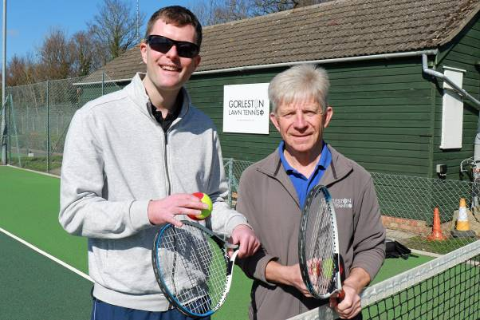

Image: Vision Norfolk Great Yarmouth Hub Coordinator Edward Bates (left) and tennis coach Mike Reynolds standing on a tennis court at Gorleston Tennis Club getting ready for a tennis taster session.

**In This Edition**

Vision Norfolk News – Page 1 - Updates from your local sight loss charity

Children, Young People and Families - Page 9 - Learn about our services for local people aged 0 to 25 and their families

Equipment and Technology – Page 11 - Updates about equipment and technology including upcoming events and opportunities

Regional Updates and Activities – Page 14 - Updates from Norwich and South Norfolk, West Norfolk and East Norfolk including news from our community hubs and upcoming events and activities

Poets’ Corner – Page 38 - We remember David Foulds, an avid poet and member of our community

Contact Details – Page 40 - Find out how to reach us with your questions

**King Charles III Announced As Patron of Vision Norfolk**

King Charles has been announced as the Patron of your local sight loss charity.

Vision Norfolk was first granted royal Patronage over 122 years ago and our records show The Prince of Wales passed by the Charity in 1880. In 1901 King Edward VII, previously The Prince of Wales, agreed to continue his Patronage of the charity which was then continued by King George V, King George VI and Queen Elizabeth II.

We are one of a number of organisations across the UK which has received the Patronage of The King on the first anniversary of the Coronation of King Charles and Queen Camilla.

The announcement is a great honour, which will help us attract support from across the county.

“We were of course very sad when the late Queen, who had been our Patron for many years, died in 2022,” said Vision Norfolk Chair of Trustees Karen Norton.

“We were delighted to hear, on the first anniversary of Their Majesties’ coronation, that Vision Norfolk has been chosen as one of the organisations where The King will assume the Patronage from his late mother. We are enormously grateful that he has chosen to show his support for the important work that we do in this way.

“A Royal Patronage is the highest endorsement a charity can receive, and is enormously helpful when it comes to attracting support from people in Norfolk.”

A statement from Buckingham Palace said, “Royal Patronage highlights the vital work of these organisations and allows their many achievements and valuable contributions to society to be more widely recognised and promoted.”

The late Queen visited Vision Norfolk in 2010 to visit the new Bradbury Activity Centre in Norwich. She was Patron of 492 organisations, of which 376 will be retained by King Charles, or taken on by Queen Camilla or other members of the Royal Family.

**Meet Sophie**

Sophie Chapman-Smith has recently joined the Vision Norfolk team as a Volunteer Engagement Coordinator.

She will be working part-time focusing on volunteers supporting local vision impaired people in hospitals and out in the community.

Volunteers are an essential part of the Vision Norfolk community, providing support to staff and services users across the county. We are also working on further plans to grow the volunteering team in the coming months.

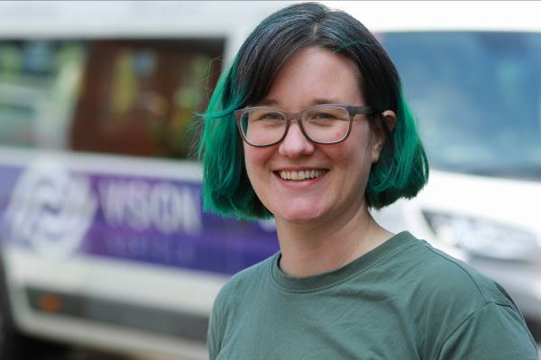

Image: Profile photo of Volunteer Engagement Coordinator Sophie Chapman-Smith with a Vision Norfolk van in the background

**Summer Fundraisers**

One fundraiser is taking on the challenge to swim the length of Lake Coniston in Cumbria end to end, which is a total of 5.25 miles, in support of Vision Norfolk and Guide Dogs UK.

Clare McCarthy will be swimming with the aid of her dedicated guide swimmer on Saturday 22nd June. You can find out more about Clare’s journey as a severely sight-impaired swimmer on the news section of our website and support her swim through her Just Giving page “Clare’s fundraiser for Vision Norfolk”.

The Mulbarton Allotment and Leisure Gardens Association organises the annual Mulbarton Open Gardens event to show off the skills of local gardeners while raising money for good causes. This year the proceeds are going towards Vision Norfolk! The event is on Sunday 21st July from 10am until 4pm. Entry is £5 for an adult and free for anyone under 14. For further information contact the parish council on 01508 578 134.

We want to say a huge thank you to all our supporters including: the Links Golf Club in West Runton, the 1st Corpusty and Saxthorpe Brownie pack, the Norwich City College Hospitality Enterprise Course, Acle Blind Club and many others!

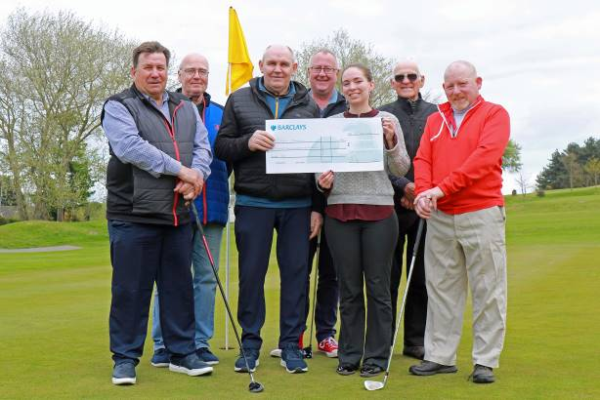

Image: Six members of the Links Golf Club in West Runton on the golf course handing over a cheque of £2514.04 to the Vision Norfolk Community Fundraising Officer.

**Services Highlight**

**Telefriends – A Friendly Listening Ear**

Our Telefriends service offers a free friendly confidential listening ear to anyone experiencing sight loss across the Norfolk area.

The service gives you the opportunity to set up a weekly call with a Vision Norfolk volunteer to check in and chat, with calls being made for as long as you require the service. The same volunteer will call each week, giving you the chance to get to know each other. You do not have to talk about sight loss, you can simply have a chat about your memories or what is going on in your life. All the volunteers have access to information about our services so they can also help recommend activities and services, answer questions or pass your feedback on to the right members of staff.

All our volunteers are trained and DBS checked. Many have experience with sight loss and work within other parts of the charity.

This service is designed to give you a chance to talk about your concerns and reduce social isolation. Please note this is not a professional advice or counselling service.

We have some keen friendly volunteers waiting on the other side of the phone right now so please get in contact with Mark on 01603 573000 Extension 341 or mark.smith@visionnorfolk.org.uk, if you would like to give Telefriends a try.

**Community Outreach – A Day in the Life of a Community Outreach Worker**

Meet Sue Warnes

I have been a Community Outreach Worker for Vision Norfolk since July 2023. I moved here after a 30 year career as a Rehabilitation Worker for People with Vision Impairment and love every minute of my new role.

What does your average day look like?

There is no such thing as an average day – every day throws up new challenges with new people who all have varying needs and situations. I have to think on my feet and adapt to each of these individual people, listening to them and working together to put plans in place to support them to adjust and live as independently as possible. My day starts and usually ends with checking emails, recording visits and making any onward referrals needed to other agencies such as Guide Dogs, Blind Veterans, social care services and so on. I can have anywhere between 1 and 4 home visits a day and can see between 8 and 10 people each week.

What type of things do you talk about on your visits?

My first visit is usually a general chat to help me get to know the person and for them to start to feel comfortable with me. I talk about Vision Norfolk and the services and activities we offer. It is the person’s chance to share their story and we talk about anything from daily living worries, benefit applications, emotional aspects and family and carer needs. I can support with demonstrating equipment, filling in forms, advising about other services and making referrals to other agencies such as social care, occupational therapy, talking book providers and so on. I can support people to access our activities giving them the confidence to then attend on their own. I also attend promotional events to promote Vision Norfolk and to try to reach out to people who may need our support.

What do you like most about your job?

I like the variety of the role and the autonomy that I have. The job is neither dull nor predictable. The people I support are interesting, inspiring and resilient and it is a pleasure to be able to enable them to continue to live fulfilling and independent lives following their vision impairment diagnosis.

**Children, Young People and Families**

The Children, Young People and Families Department have continued their efforts in organising a variety of events tailored specifically for vision impaired children and their families. From dynamic workshops to inclusive recreational activities, the department’s goal is to craft memorable experiences that nurture independence and confidence. These events serve not only as opportunities for children to explore their passions and cultivate new skills but also as supportive environments for families to connect, exchange experiences and access valuable resource.

Among the outings organised by the CYPF department were visits to notable destinations such as the Time and Tide Museum, Colchester Zoo, and Hautbois, ensuring that children enjoy diverse and enriching experiences tailored to their individual needs and interests.

Additionally, in April, we launched a new weekly tennis session in partnership with the East Anglian Tennis and Squash Club. Furthermore, our recently launched Parent Support Groups will continue to convene every second Monday of each month at our Great Yarmouth Hub. They will also gather every second and last Wednesday at the Bradbury Activity Centre in Norwich, offering additional chances for parents to connect and access support. As we transition into the summer months, we are planning to take the children, young people and families to exciting outdoor activities such as Pleasurewood Hills, adventure golf, bowling, and sailing.

Throughout the spring season, we continue to provide one-on-one emotional and practical support for families, offering an essential service to help them understand the impact of vision impairment. Our assistance includes advice on benefits, grants and funding available for children with vision loss, along with referrals to various relevant services and organisations.

We welcome your input and encourage you to share suggestions for new activities and other ways we can offer support. Please reach out to CYPF@visionnorfolk.org.uk with any questions or ideas for 2024.

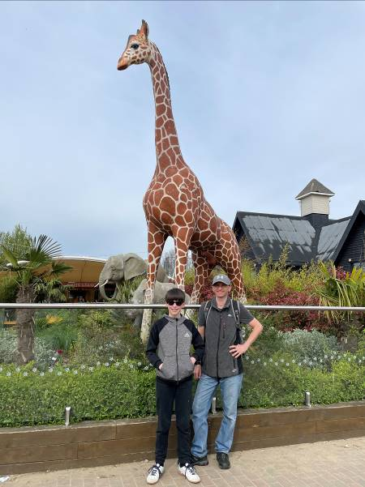

Image: A boy and a man standing in front of a statue of a giraffe

**Equipment and Technology**

If you have any questions about daily living equipment we can provide support at our community hubs in Norwich, King’s Lynn and Great Yarmouth or over the phone. Our Community Outreach Workers are also available for home visits where they can discuss which of our services may be of interest to you, including discussing equipment and how your living space can best work for you.

To find out more please get in contact with John at 01603 573000 Extension 323.

**Opportunities to Talk About Technology**

Tea and Tech – Norwich, Last Monday of the Month, 1:30pm-3:30pm

Rachael and Darryl Andrews invite you to come along to the Norwich Hub and chat about your tech products. This is not a training session but a discussion session for likeminded people to talk about technology. If you might be interested please contact Richard at 01603 573000 Extension 322.

Technology Sessions with RNIB – King’s Lynn, Monthly on a Wednesday (17th July, 14th August, 18th September), 11am-3:45pm

These are one-to-one problem solving sessions with Mohammed Atif, Technology for Life Coordinator at RNIB, to help you with any issues you are having with digital technology and devices. Free 45 minute sessions must be booked ahead of time. If you might be interested please contact Penny at 01553 660808.

Technology Support Sessions – Great Yarmouth, Last Wednesday of Each Month, 1pm-2pm

One of our volunteers is offering his help and support to anyone who might be experiencing issues with their technology. Please be aware this will need to be booked in advance. If you might be interested please contact Catherine at 01493 745973.

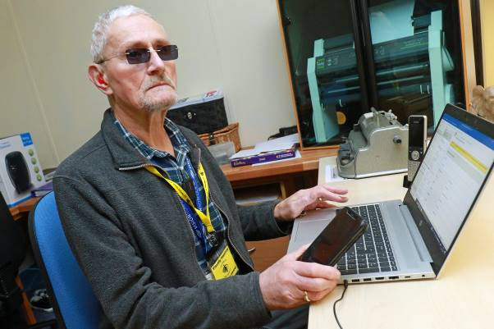

Image: Vision impaired volunteer David Page sitting in front of a laptop computer.

**Equipment Tip – Air Fryers**

Norfolk has recently purchased three talking air fryers for demonstration at each of our community hubs and for use in our cooking and life skills classes.

An air fryer is essentially a mini oven that can sit on a counter top. Their heating elements sit on top of the appliance and hot air is moved around a small cooking drawer by a powerful fan. They are generally considered quicker and more energy efficient than a traditional oven as heating is more concentrated.

Air fryers can be used to cook, heat, fry and bake food. Recipes exist for everything from roasted potatoes and veg to baked goods. The Norwich cooking group has so far successfully made scones, muffins and flatbreads in our air fryer and plan to continue to experiment with other recipes.

There are a wide variety of air fryers available for purchase with prices from around forty pounds to a couple hundred pounds. Some are more accessible or adaptable depending on your needs. The “talking air fryers” have dials that are tactile and audible so it is easier to find the desired setting. Others have tactile dials that do not speak but can be adapted with the use of bump-ons. There are air fryers with large touchscreen dials and bright lights that mark when the food is ready. These versions may be useful to some people with low vision but difficult to use for others as a touch screen cannot be adapted with bump-ons.

One slight drawback we have found with air fryers is that it can be a bit tricky getting the food out of the drawer, as both the drawer and the food are hot. This can often be solved by checking the model before buying it as different models have different solutions to this problem including cool handles which allow the drawer to be easily lifted out and placed on a heatproof surface.

Alternatively a silicon or foil container can be fashioned to allow food to be lifted out easily. Another potential downside of an air fryer is that they are much smaller than a traditional oven, so it can be difficult to make large amounts of foods.

If you want to have a chat about air fryers and how they can be adapted you are welcome to come into one of the Vision Norfolk community hubs or join one of our cooking or life skills classes.

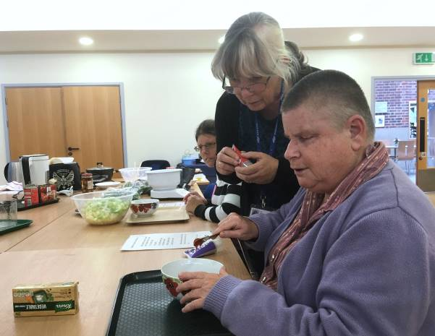

Image: Cooking with Sue – Norwich: A woman measuring tomato paste into a bowl while another woman watches over her shoulder. In the background the table is covered with bowls and various cooking instruments.

**Norwich Hub Updates**

**Pottery**

Clare from Wayside Pottery brought her potter’s wheel into the Norwich hub for two small group pottery classes in April and May. Participants had the chance to have a go with the wheel and enjoy one-to-one instruction. The resulting pottery was then fired and glazed so that participants could take home their unique creations.

We have had such positive feedback from these classes that we have worked to set up more sessions in July and August. Please find further details in the activities list or by getting in contact.

**Willow Weaving**

Jonathon Carrie from Norfolk Hedge Baskets ran a series of willow weaving workshops in our Norwich Hub throughout the spring. Participants started by making willow sunflowers before going on to make their own willow baskets.

We are hoping to run more workshops later in the summer so please get in contact to let us know what might interest you.

**Book Lovers Wanted in Diss**

Our audiobook club in Diss is looking for more participants to join the group. The group meets once a month at the Diss Library to chat about that month’s chosen audiobook over tea or coffee.

The monthly meetings are informal, friendly and everyone has an opportunity to give their thoughts and opinions. Books are supplied for free on an USB memory stick.

Discussions and book choice are led by the members of the group and volunteer Hazel assists the group members in the session.

The group meets at Diss Library on the fourth Friday of the month from 2pm until 3:30pm.

**Glaucoma Awareness Week**

National Glaucoma Awareness Week runs from the 24th to the 30th June. It was started by the charity Glaucoma UK as an annual awareness-raising opportunity to encourage people across the UK to talk about glaucoma.

Glaucoma is the name given to a group of eye conditions where there is damage to your optic nerve. It is the second most common cause of sight loss in the UK (after age related macular degeneration). It is caused by increased pressure in the eye, usually triggering slow loss of vision. This happens when fluid isn’t able to drain away from the eye as it normally would. The build-up of pressure can also restrict blood flow to the optic nerve, which connects the eye to the brain and causes sight loss. We have teamed up with Glaucoma UK to start a Glaucoma Support Group at the Norwich Hub and we would love to have some more participants join in. The group is a self-help and discussion session and we often have speakers in to talk about glaucoma, macular degeneration and other interesting subjects.

**Mobile Planetarium**

A group from the Norwich Hub will be heading to Dussindale Community Centre on Monday 5th August to experience a mobile planetarium. This planetarium show will be projected on the inside of an inflatable dome with an exploration of the stars guided by an expert from Wonder Dome. If you are interested in joining please get in contact.

For the full details of these and other social, practical and creative activities across Norwich and South Norfolk please check out the following list.

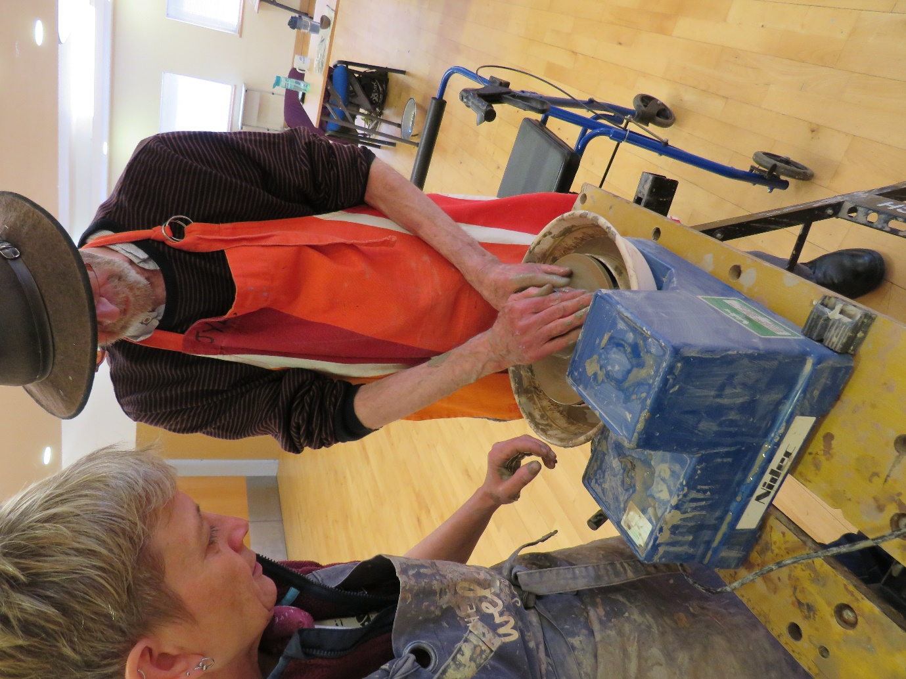

Image: A man standing at a pottery wheel while a woman stands next to him.

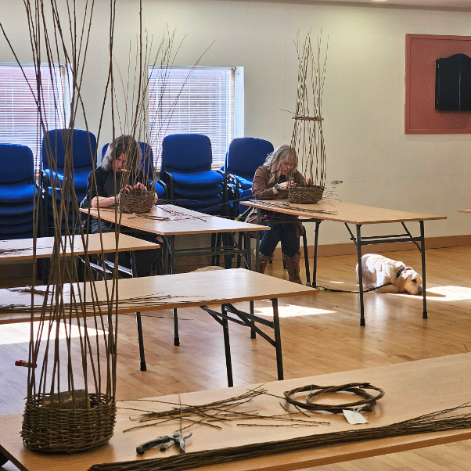

Image: Two people sitting at long tables working on weaving baskets while a dog lies in a sunny spot.

**Norwich and South Norfolk Activities**

Unless otherwise stated please contact Richard at 01603 573000 Extension 322 or richard.polley@visionnorfolk.org.uk.

**Regular Activities**

Arts and Crafts – Norwich, Every Thursday 10am-12:30pm

Undertake a variety of arts and crafts with support from Helen and the volunteers. Contact Mark on 01603 573000 Extension 341.

Audiobook Clubs

Our friendly, informal audiobook clubs offer a chance to get together and enjoy a chat about a chosen book. The book clubs are free to join and we can supply a memory stick player if you don’t have one. Contact Mark on 01603 573000 Extension 341.

Diss Audiobook Club – 4th Friday of the Month, 2pm-3:30pm

Norwich Audiobook Club – 2nd Monday of the Month, 1:30pm-3pm

Bowling – Norwich, 2nd and 4th Friday of the Month, 12:15pm-5pm

Come and enjoy some friendly competition with ten pin bowling at Namco Funscape. Transportation available from the Norwich Hub. Regular bowling fee to be paid to Namco Funscape.

Braille Classes – Norwich, Every Thursday, By Appointment

Join our Braille class taught by one of our volunteers. The classes are small, usually on a one-to-one or one-to-two basis.

Coffee Mornings and Socials

Come and enjoy a cup of coffee and a chat at one of our socials.

Attleborough Drop-in Cafe – Fortnightly from 17th June, 11am-12:30pm, contact Chris Linstead at 07743 921430

Norwich Coffee Morning – Last Monday of the Month, 10am-11:30am

Norwich Drop-in Café – Fortnightly from 26th June, 11am-12pm, please contact Jo at 01603 573000 Extension 454

Thetford Drop-in Café – 4th Wednesday of the Month, 2pm-3:30pm, contact Chris Linstead at 07743 921430

Cooking with Sue – Norwich, Monthly on a Thursday (20th June, 18th July, 29th August, 26th September), 2pm-4pm

Each month we will be running a cookery lesson at our Norwich Hub teaching practical skill that can be used at home.

Creative Writing – Norwich, 3rd Tuesday of the Month, 2pm-3:45pm

Join a creative writing group that will give you the opportunity to express yourself through the written word. Contact Mark on 01603 573000 Extension 341.

Darts – Norwich, 1st and 3rd Friday of the Month, 1pm-3pm

Join us for a few friendly games of darts. Volunteers are around to help you position or read the numbers on the board if needed.

Glaucoma Support Group - Norwich, 2nd Friday of the Month, 2pm-3:30pm

We are working with Glaucoma UK to create a self-help and discussion session for local people living with glaucoma. We sometimes have speakers to talk about glaucoma and other subjects.

Macular Society – Norwich, 2nd Friday of the Month, 12pm-1:30pm

This group is organised and run by the Macular Society. Vision Norfolk staff usually give an update on new equipment and activities and there are sometimes guest speakers.

Photography Group – Norwich, 1st and 3rd Friday of the Month, 1:30pm-3:30pm

The first meeting in each month is an outdoor photoshoot and the second is an indoor opportunity to review photographs. Some outing may have a cost for refreshments. Contact Mark on 01603 573000 Extension 341.

Sailing – Norwich, Fortnightly from 20th June, 12:30pm-5pm

Come and enjoy an afternoon of sailing on the Norfolk Broads. Trips cost £18 per person. Contact Mark at 01603 573000 Extension 341.

Seated Yoga – Norwich, Every Tuesday, 1pm-2pm and 2:15pm-3:15pm

Come stretch and relax with yoga. Sessions are designed to be accessible to all abilities and levels of experience. We have spaces available in both the seated and advanced yoga sessions.

Short Mat Bowls – Norwich, Every Tuesday, 10am-12pm

Come and enjoy some friendly competition with the traditional British game short mat bowls.

Tandem Cycling – Norwich, By Appointment

Tandem cycling allows you to continue to enjoy a good (and safe) bike ride regardless of your vision loss. A sighted guide sits at the front to steer and describe. Sessions are subject to volunteer availability.

Tea and Tech – Norwich, Last Monday of the Month, 1:30pm-3:30pm

Rachael and Darryl Andrews invite you to come along to the Norwich Hub and chat about your tech products. This is not a training session but a discussion session for likeminded people.

Guide Walks – Transportation From Norwich

We run a variety of guide walks during the summer months. Please get in contact for more information.

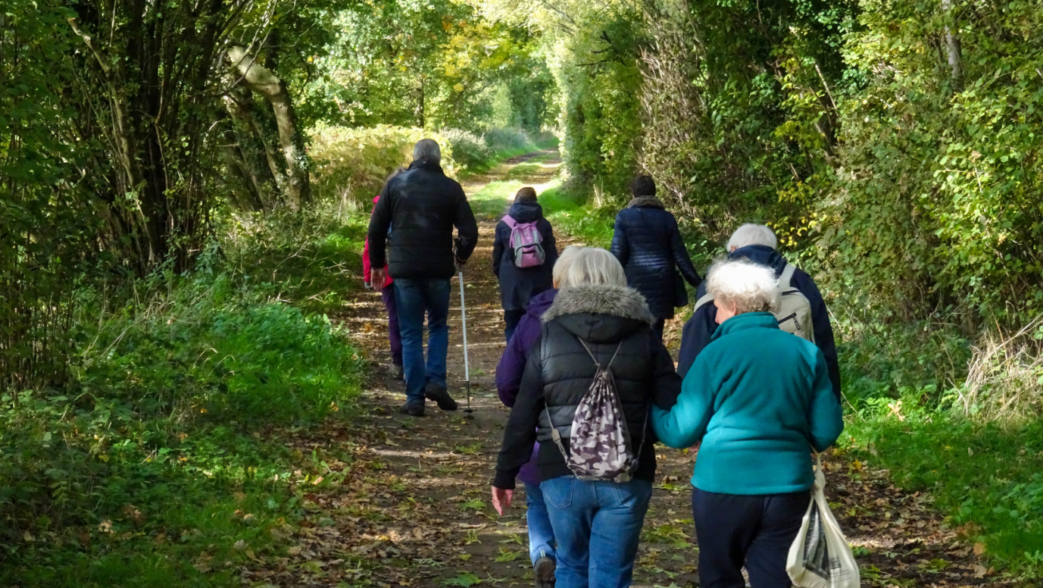

Image: A group of eight people from behind walking on a path through trees. Light breaks through the trees in places and there are leaves on the ground.

**Special Events**

Pottery Sessions – Norwich, 4th July and 8th August, 10am-12pm

Try your hand at pottery with the help of an expert at one of our small group pottery workshops. Contact Mark on 01603 573000 Extension 341.

Mulbarton Open Gardens Visit – Transportation from Norwich, 21st July, 11am-4pm

This annual event raises funds for charity by opening gardens around the village to the public. Join us on a minibus from the Norwich Hub to explore all the various open gardens, and refreshments will also be available. Proceeds from this event are being donated to Vision Norfolk. Contact Mark on 01603 573000 Extension 341.

Mobile Planetarium – Norwich, 5th August, Afternoon

Join a group on a minibus from the Norwich Hub to enjoy a mobile planetarium show at Dussindale Community Centre. The show will take place inside a Wonder Dome inflatable mobile planetarium.

Theatre Trip: Murder on the Orient Express – Norwich, 18th September, 2:30pm-5pm

Join Vision Norfolk for an audio described performance of Murder on the Orient Express at Norwich Theatre Royal. Tickets cost £38.50 including a free sighted guide ticket if required. Book by 14th June by calling Mark on 01603 573000 Extension 341.

Theatre Trip: Carlos Acosta’s Nutcracker in Havana – Norwich, 2nd November, 2:30pm-5pm

Join Vision Norfolk for an audio described performance of Carlos Acosta’s brandnew production Nutcracker in Havana at Norwich Theatre Royal. Tickets cost £58 including a free sighted guide ticket if required. Book by 26th July by calling Mark on 01603 573000 Extension 341.

**King’s Lynn Hub**

**New Archery Sessions in Fakenham**

We have a new archery group in Fakenham designed to be accessible for local people living with sight loss.

Following on from the success of our Downham Market archery sessions we have recently started free archery sessions in Fakenham. Taking part in the first meeting was Jason Beasley, a former scaffolder from King’s Lynn who lost his sight last September, and who is now severely sight impaired.

“I really enjoy coming here and doing the best I can. One important aspect is the social side of it. Having recently lost my sight, it is inspiring to talk to others who have learnt how to live a fulfilled life, and to share their experiences. Andy is a really natural coach who makes it seem the most natural thing in the world that vision impaired people should be doing archery.”

Sessions take place on the 4th Wednesday of the month from 2pm until 4pm at Hempton Memorial Hall.

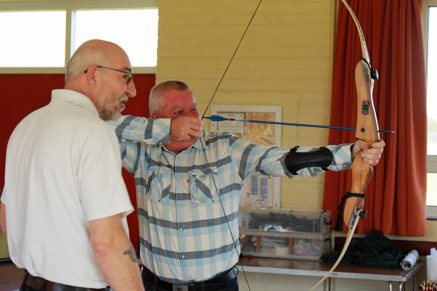

Image: Archery participant Jason Beasley holding a notched arrow while being instructed by Archery GB coach Andy Beer

**Tandem Cycling Returns**

We have started our tandem cycling sessions for the summer 2024 season!

We held our first taster in May to give interested cyclists a chance to meet our lovely tandem pilots and do small rides around North Lynn Industrial Estate to see how they liked the experience.

We will be running more sessions throughout the season with rides out and about in the local countryside. If you interested in taking part in any future tandem sessions please get in contact for more information.

**Other New Activities**

We are trying to reach out to more vision impaired people across the West Norfolk area, including those who may struggle to attend our current activities.

Our West Norfolk team have set up new activities in hopes of meeting you out where you are.

This includes a coffee morning to meet and chat with other local people with sight loss in Hunstanton. There are also drop-in cafes in Swaffam and King’s Lynn where you can meet Chris, the Community Outreach Worker for West Norfolk, and chat to her about living with sight loss and how we can support you. There is also a new Bowls club in Fakenham.

Please let us know what support you would like in your area by stopping by one of our drop-in sessions or getting in contact.

For the full details of these and our other social, practical and creative activities across the West Norfolk area please check out the following list.

**West Norfolk Activities**

Unless otherwise stated contact Abbi at 01553 660808 or kingslynnhub@visionnorfolk.org.uk.

**Regular Activities**

Archery

Join one of our archery sessions designed to be accessible for all abilities and skill levels.

Downham Market Archery - 1st Monday of the Month, 4pm-6pm

Fakenham Archery – 4th Wednesday of the Month, 2pm-4pm

Art Workshops – King’s Lynn, 1st Friday of the Month, 1pm-3pm

We are holding small art workshops with painting, print making, collage and more.

Audiobook Clubs

Our friendly, informal audiobook clubs offer a chance to get together and enjoy a chat about a chosen book. The book clubs are free and we can supply a memory stick player. Contact Mark on 01603 573000 Extension 341.

Dereham Audiobook Club – 3rd Wednesday of the Month, 10:30am-12pm

Fakenham Audiobook Club - 3rd Monday of the Month, 10:30am-12pm

Gaywood Audiobook Club – 1st Thursday of the Month, 2pm-3:30pm

Choir – King’s Lynn, Fortnightly from 12th June, 1pm-3pm

Join the Vision Norfolk Choir to improve your mental wellbeing, meet new people and most importantly have fun.

Coffee Mornings and Socials

Come and enjoy a cup of coffee, a slice of cake and a chat about everything and anything at one of our socials.

Downham Market Social – 4th Wednesday of the Month, 11am-1pm

Fakenham Coffee Morning – 4th Tuesday of the Month, 10am-12pm

Hunstanton Drop-in Café – 2nd Tuesday of the Month, 10am-12pm

King’s Lynn Coffee Morning – 1st and 3rd Tuesday of the Month, 10am-12pm

King’s Lynn Drop-in Café – 3rd Wednesday of the Month, 10am-12pm

Swaffam Drop-in Café – 3rd Thursday of the Month, 10am-12pm

Darts and Shuffleboard – King’s Lynn, 4th Thursday of the Month, 10am-12pm

Come and enjoy your choice of darts or shuffleboard with assistance (and competition) available as needed.

Knitting – King’s Lynn, 2nd Tuesday of the Month, 1:30pm-3:30pm

Whether you are a complete beginner who would like to take up knitting or a seasoned knitter, our sessions are a fun and sociable way of getting together with fellow yarn fans.

Photography Club – King’s Lynn, 3rd Monday of the month, 2pm-4pm

The group alternates sessions between outings to photoshoots and sessions in the hub reviewing photographs.

Pub Club - Varies, 2nd Monday of the Month, 12pm-2pm

A relaxed and friendly group that meet for a chat over lunch at local pubs.

Short Mat Bowls – Fakenham, 1st Friday of the Month, 2pm-4pm

Come and enjoy some friendly competition with the traditional British game short mat bowls.

Sit Fit – Downham Market, 3rd Friday of the Month, 1:30pm-3:30pm

A seated exercise class suitable for all adults regardless of age, gender or ability.

Tandem Cycling – King’s Lynn, Dates To Be Confirmed

Tandem cycling allows you to continue to enjoy a good (and safe) bike ride regardless of your vision loss. A sighted guide sits at the front to steer and describe. Get in contact for more details.

Technology Sessions – King’s Lynn, Monthly on a Wednesday (17th July, 14th August, 18th September), 11am-3:45pm

These are one-to-one problem solving sessions with Mohammed Atif, Technology for Life Coordinator at RNIB, to help you with any issues you are having with digital technology and devices. Free 45 minute sessions must be booked ahead of time.

Walking Club – King’s Lynn, 4th Monday of the Month, Times Vary

We have started a new regular walking group with transportation available from the King’s Lynn Hub.

**Great Yarmouth Hub Updates**

**Tennis**

On the 23rd April Vision Norfolk partnered with LTA-accredited coach Mike Reynolds and Gorleston Tennis Club to hold a tennis taster session specifically designed for local people living with sight loss.

“Vision impaired tennis has been around for a number of years, and we are hoping to show that even those with serious sight loss can take part in the sport,” said Mr Reynolds.

“We use special tennis balls, some of which have beads or bells in them so that they make a noise as they move. For those with a little more sight, we use larger than normal balls which are designed to travel more slowly through the air.”

Depending on the level of their vision impairment, players are allowed to let the ball bounce twice or even three times before hitting it to enable them to gauge where it is on the court.

Further sessions are now available on the 2nd Tuesday of each month at Gorleston Tennis Club. Please be aware that we are not running transport from the hub, but there are local bus stops close by where staff can meet you if needed.

**Fishy Friday**

Did you know the East Anglian fishing industry can trace its roots all the way back to before the Norman’s arrived in 1066?

Be part of that proud history (no hard labour required) by joining Vision Norfolk for an afternoon fish and chips. Meet some new people, have a chat and enjoy a bit of the bounty of the sea at Fishy Friday at the Great Yarmouth Hub.

The group meets on the 1st Friday of each month from 1pm until 2pm. It will cost around £6.50 per person to cover the fish and chips.

**Coffee and Snooker in Martham**

The monthly Martham Coffee Morning has secured access to the full sized snooker tables upstairs at Martham Village Hall so you can enjoy a good old game of snooker while chatting with other local people living with sight loss!

**More Book Lovers Wanted**

The Great Yarmouth and Cromer audiobook clubs are looking for more members to join their monthly meetings.

“With the onset of sight loss, many people find it difficult to enjoy the pleasures of reading,” said volunteer Alison Bates, who runs the Great Yarmouth group. “This is where audio books come into play, and they are a vital means of enjoying a favourite book.

“Reading is always one of the things that people miss when they start losing their sight, along with social interaction. The audio book club provides both of these things: companionship as well as lively conversation about the book we have all been listening to

“We read a huge variety of books – they are certainly not all highbrow or literary classics! The titles are generally the kind of books that most enthusiastic readers might find on their shelves. Our meetings are informal and friendly, we try to make them fun.”

Check out the following activities list for information on all our new and returning opportunities that you can get involved with across East Norfolk.

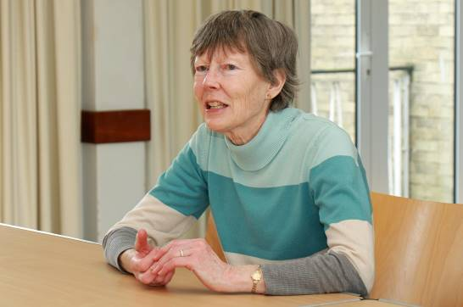

Image: Vision Norfolk volunteer Alison Bates, who runs the monthly Great Yarmouth audio book club.

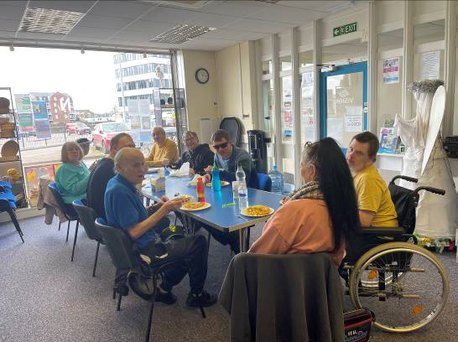

Image: Nine people sitting around a table in the Great Yarmouth Hub enjoying fish and chips as part of Fishy Friday.

**East Norfolk Activities**

Unless otherwise stated please contact Catherine at 01493 745973 or greatyarmouthhub@visionnorfolk.org.uk.

**Regular Activities**

Audiobook Clubs

Our friendly, informal audiobook clubs offer a chance to get together and enjoy a chat about a chosen book. The book clubs are free to join and we can supply a memory stick player if you don’t have one. Contact Mark on 01603 573000 Extension 341.

Great Yarmouth Audiobook Club – Last Friday of the Month, 1:30pm-3pm

Cromer Audiobook Club – 3rd Monday of the Month, 2pm-3:30pm

Bowling – Great Yarmouth, 25th June Then Last Tuesday in Alternate Months, 12pm-3pm

The Great Yarmouth Hub runs group bowling trips to Wellington Pier. Places are limited.

Clip and Climb – Great Yarmouth, 30th July and 24th September, 3pm-4pm

Ever fancied rock climbing? Clip n’ Climb is made up of a number of unique climbing elements at the indoor climbing gym at the Great Yarmouth Marina Centre.

Coffee Mornings and Socials

Come and enjoy a cup of coffee, a slice of cake and a chat about everything and anything at one of our socials.

Great Yarmouth Coffee Morning – Every Wednesday, 10am-12pm

Cromer Coffee Morning – Last Wednesday of the Month, 10am-1pm, Contact Karl at 07864 615929

Martham Coffee Morning (and Snooker) – 3rd Monday of the Month, 10am-12pm, Contact Matthew at 01603 573000 Ext. 455

Fishy Friday – Great Yarmouth, 1st Friday of the Month, 1pm-2pm

Meet other local people living with sight loss and have a chat over fish and chips. Costs £6.50 per person to cover the food.

Games Morning – Great Yarmouth, Every Thursday, 10am-12pm

Join our fun and welcoming games to try out cards, bingo, dominoes and floor and table games.

Knit and Natter – Great Yarmouth, 2nd Thursday of the Month, 1pm-2pm

Join Norfolk Knitters at our Knit and Natter group where we learn together how to knit along with having a good natter and chance to meet new people.

Life Skills – Great Yarmouth, 2nd Monday of the Month, 2pm-4pm

Each month we will be running a cookery lesson at the Great Yarmouth Hub. Sessions will introduce adaptive technology and teach practical skills designed to be transferable to your home kitchen.

Seafront Walks – Great Yarmouth, Last Thursday of the Month, 1pm-3pm

Join us for a breath of fresh air and a leisurely stroll along the one of our many local seafronts including a stop for refreshments along the way.

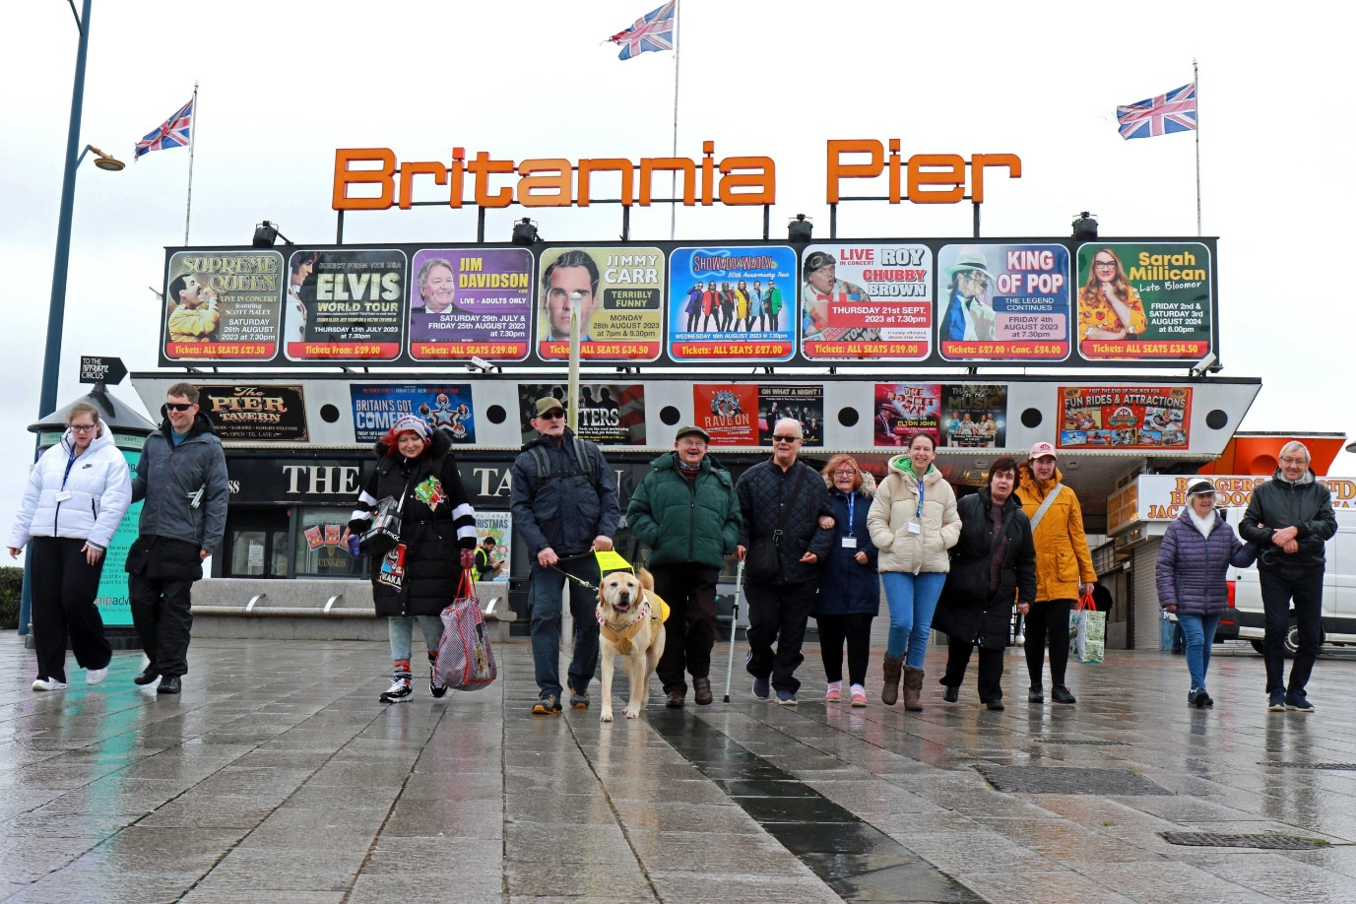

Image: Twelve walkers and one guide dog posing in front of the entrance to Britannia Pier on an overcast day.

Technology Support Sessions – Great Yarmouth, Last Wednesday of Each Month, 1pm-2pm

These sessions are run on an appointment basis by one of our volunteers who is offering his help and support to anyone who might be experiencing issues with their technology. Please be aware this will need to be booked in advance.

Tennis – Gorleston, 2nd Tuesday of the Month, 10:30am-12pm

Give tennis a try at special sessions led by LTA-accredited coach Mike Reynolds.

Weaving Group – Great Yarmouth, Every Friday, 10am-12pm

Use different types of soaked cane to make baskets of all shapes and sizes.

**Special Events**

Railway and Water Cruise - Great Yarmouth, 12th July

Join a mini bus from Great Yarmouth for a trip from Wroxham to Aylsham on Bure Valley Railway followed by a water cruise on the Broads in Horning.

**Poet’s Corner**

In December we lost one of the members of our community. David Foulds was a member of the short mat bowls group, writing group, resident at Hammond Court and a friend to many. He will be missed.

**A Collection of Poems by David Foulds**

**Calming**

All week a storm raged loud along our coast,

A howling, blustering gale with squalls

That, thrashing the hazel’s leafy branches

Into a shrieking, sputtering frenzy,

Drew in a dense, close curtain of surrounding noise

And blotted out all distant sounds.

Then in the early hours this wild wind dropped.

I heard leaves rustling on the oak two gardens down;

The barking of a village dog;

The hoot of hungry owl, reply of distant mate.

And further, further off in the ever settling air

The muffled crash of storm tide thundering onto shingle beach.

**Nocturne**

Summer night,

distant thunder; Surf drums and

washes over shingle shore.

**Bats**

Star-time rising;

They flitter around the roof-tops;

Dodge, duck, dive and twist.

**Dawn**

A brightening eastwards;

Beyond the dark hill

the allotment cock crows.

© David Foulds

**Contact Us**

For further information on how we can support you and how you can get involved:

Website: visionnorfolk.org.uk

Telephone: 01603 573000

Email: office@visionnorfolk.org.uk

Our hubs can be found at:

**Norwich**

Bradbury Activity Centre, Beckham Place Edward Street, Norwich, NR3 3DZ

Telephone: 01603 573000

Email: office@visionnorfolk.org.uk

**King’s Lynn**

Unit 3, Dundee Court, Hamburg Way King’s Lynn, PE30 2ND

Telephone: 01553 660808

Email: kingslynnhub@visionnorfolk.org.uk

**Great Yarmouth**

12 Hall Quay, Great Yarmouth, NR30 1HP

Telephone: 01493 745973

Email: greatyarmouthhub@visionnorfolk.org.uk

Registered charity no. 1206599