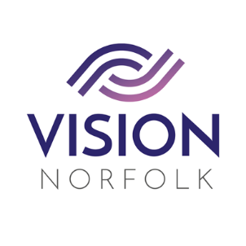

Role Title: | Volunteer Minibus Driver
Hours and Location: | Details agreed after training. Drivers required across the county
About the organisation: | We are Vision Norfolk and our mission is to support people living with sight loss to live active, independent and fulfilled lives.
About the role: | As a minibus driver, you will help our clients to access activities and events outside of our hubs. The role requires you to:  - Ensure that our clients feel comfortable travelling with you as their driver.  - Support our clients to feel confident attending activities. You may also be asked to accompany them to an activity.  - Support our clients to manage their transport needs as independently as possible.  - Report any incidents, accidents or near miss situations to the charity and follow our procedures.  - Follow traffic law regarding reporting of road traffic collisions.  - Adhere to the Highway Code at all times when driving.  - Show a caring and kind attitude towards our clients.
Skills / Experience needed: | Experience of driving a minibus would be advantageous but not essential.  Ability to undertake and pass MIDAS minibus training is essential for this role.
Benefits of Volunteering in this role: | Becoming a volunteer is a wonderful opportunity to make a difference and support your local community. Vision Norfolk also offers:  - Regular advice, support, and training  - Payment of out of pocket expenses agreed in advance
Contact details: | To discuss this role or other opportunities please contact the Volunteer Engagement Coordinators on 01603 573000 or volunteers@visionnorfolk.org.uk. We also have application forms available on our website: www.visionnorfolk.org.uk

