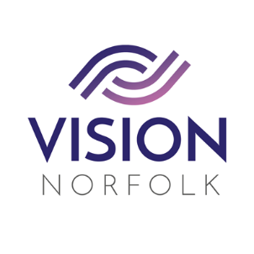

Role Title: | Sighted Guide
Hours and Location: | Volunteers required across our three hubs – Norwich, King’s Lynn, and Great Yarmouth. Hours are flexible depending which activities you participate in and how much time you would like to commit.
About the organisation: | Vision Norfolk’s mission is to support people living with sight loss to live active, independent and fulfilled lives.
About the role: | Vision Norfolk runs numerous sports and leisure activities for people living with sight loss across Norfolk.  We are looking for friendly volunteers who enjoy talking and listening to our clients whilst guiding them around the activity or sport they are attending. You will undergo training and learn to safely guide someone with sight loss, helping them to navigate their environment and feel confident and involved. This can also include helping them to safely move around the space, join in the activity, and also describing to them what is happening and what details you can see that they might enjoy.
Skills / Experience needed: | Our volunteers will:  · Have great communication skills  · Enjoy being part of a team  · Have patience and flexibility  · Be able to undertake the role safely and effectively
Benefits of Volunteering in this role: | Becoming a volunteer is a wonderful opportunity to make a difference and support your local community. Vision Norfolk also offers:  - Regular advice, support, and training  - Payment of out of pocket expenses agreed in advance
Contact details: | To discuss this role or other opportunities please contact the Volunteer Engagement Coordinators on 01603 573000 or volunteers@visionnorfolk.org.uk. We also have application forms available on our website: www.visionnorfolk.org.uk

