**Vision Norfolk**

**Magpie News - Autumn 2024**

Welcome to the Autumn edition of Magpie News with updates from Vision Norfolk, your local sight loss charity.

If you would like this newsletter in another format please let us know by calling 01603 573000 or emailing office@visionnorfolk.org.uk. Magpie News is currently available by mail in printed, Braille or audio format on a memory stick or CD. A digital format is also available on our website and by email as a Word Document or a PDF.

Over the summer months we have continued to run a variety of social and wellbeing activities for local people living with sight loss including a baking competition, special art workshops, alpaca trekking and much more.

Vision impaired children and young people have been star gazing, outdoor adventuring, and solving puzzles with a full program of school holiday activities.

Throughout the next few months we look forward to a number of seasonal events including a Halloween Interhub Quiz and getting ready for the holiday season. We will also be settling into our new community hub in centre of King’s Lynn and celebrating the year at the Annual Public Meeting on World Sight Day

Our Eye Clinic and Community Outreach teams will continue to provide support where it is required, whether in the hospital, at home or out in the community.

**In This Edition**

Vision Norfolk News – Page 3

Updates from your local sight loss charity

Equipment and Technology – Page 11

Updates about equipment and technology including upcoming events and opportunities

Norwich and South Norfolk – Page 15

Updates from our Norwich Community Hub and upcoming events and activities

West Norfolk – Page 25

Updates from our King’s Lynn Community Hub and upcoming events and activities

East Norfolk – Page 32

Updates from our Great Yarmouth Community Hub and upcoming events and activities

Useful Information – Page 39

Learn about the Nimbus Access Card and Blind Person’s Tax Allowance

Contact Details – Page 41

Find out how to reach us with your questions

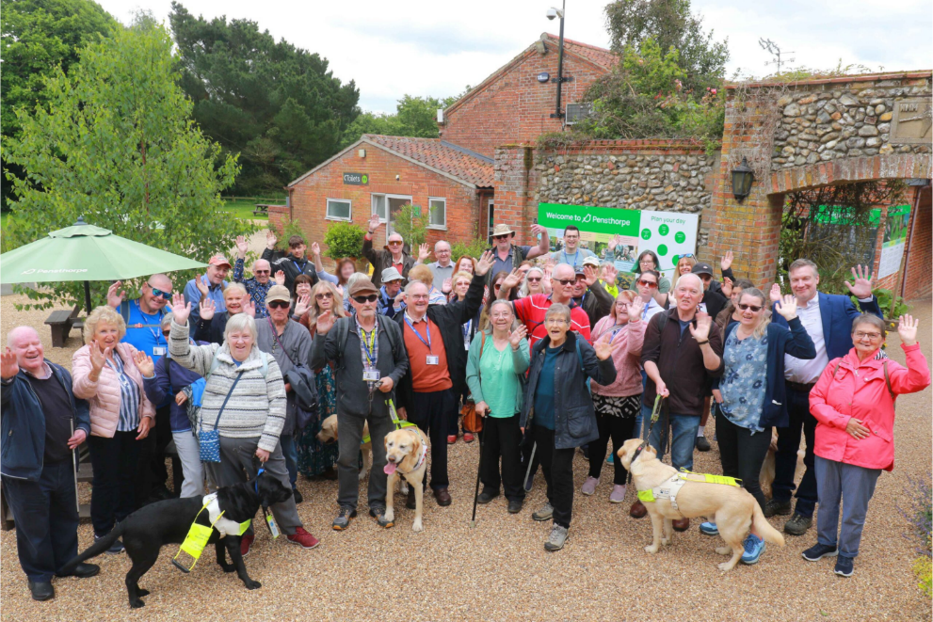

Image: A group of volunteers, guide dogs and Vision Norfolk staff waving at the camera outside of Pensthorpe Nature Reserve in Fakenham.

**Celebration Our Volunteers’ Invaluable Contribution**

It was our pleasure to invite our dedicated volunteers to join us for a special event on Tuesday, 4th June, as a heartfelt token of gratitude for their loyal service as volunteers during Volunteers’ Week.

This year, we planned a day at the picturesque Pensthorpe Nature Reserve near Fakenham and after arriving everyone had a little time to explore the grounds followed by a delightful afternoon tea in the charming Courtyard Café. Our long service volunteers were presented with certificates from our Chief Executive, Andrew Morter.

After lunch the volunteers were divided into two groups to enjoy a wardenguided walking tour through the stunning gardens and a ride on the explorer, taking them through to hidden corners of the estate. This tour would be inaccessible on foot and allowed the volunteers to learn about the incredible conservation projects and sustainable farming practices. Thankfully the weather held out until the last hour. We were so pleased to receive many cards and emails of thanks from our volunteers, we are so pleased everyone had a wonderful time.

**Annual Public Meeting**

Mark your calendar! Our Annual Public Meeting will be on Thursday 10th October, at our Norwich Community Hub, Bradbury Activity Centre, Beckham Place, Edward Street, Norwich, NR3 3DZ.

The meeting is being held to celebrate World Sight Day 2024 and present a review of our past year and our plans for the future. It is open to anyone with an interest in Vision Norfolk and refreshments will be provided.

If you would like more information or have any questions please feel free to get in contact with us by calling 01603 573000 or emailing office@ visionnorfolk.org.uk.

**Introducing Our Inclusion and Wellbeing Team**

At Vision Norfolk, we understand that staying connected, active and engaged is vital for maintaining overall physical, mental and emotional wellbeing. Our Inclusion and Wellbeing Team, made up of dedicated Activity Coordinators, is committed to offering a broad spectrum of accessible, creative, cultural, sports and social activities tailored to suit all interests and abilities.

Whether you’re looking to engage in a new hobby, meet new people or simply stay active, we have something for everyone.

Our activities take place at our community hubs and other local venues, offering flexibility and convenience. From coffee mornings, arts and craft classes, heritage and nature trips, to yoga, cycling, boccia, bowls, gardening, and photography, there’s always something exciting to look forward to. In addition, we provide a Telephone Befriending Service, designed to combat loneliness and social isolation, ensuring that no one feels left behind.

We’re always eager to hear from our community! If you have ideas for trips, events, or activities that you’d like to see added to our offerings, please don’t hesitate to let us know. You can contact Abigail, Catherine, Richard, Mark or Helen directly. Alternatively, you can speak with our Services Manager/Deputy Chief Executive, Barbara Dunn, who is also available at 01603 573000 or via email at barbara.dunn@visionnorfolk.org.uk.

We look forward to welcoming you to our activities and supporting your wellbeing journey!

For any enquiries or suggestions regarding activities in Central Norfolk, feel free to contact Richard, Mark, or Helen at 01603 573000.

**Meet Our Inclusion and Wellbeing Team**

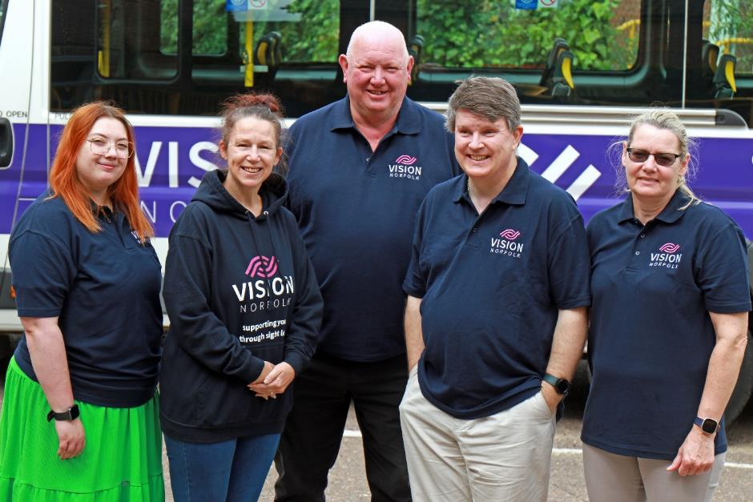

Image: The five members of the Vision Norfolk Inclusion and Wellbeing Team standing in front of a minivan. (Left to right below)

Abigail Waters is based in our King’s Lynn Hub and coordinates activities across the West of Norfolk. Abigail is your go-to person for all events and activities in this area. For more information or to explore what’s available, please contact Abigail on 01553 660808.

Catherine Bond leads our activities in the East, operating from our Great Yarmouth Hub. If you’re located in or around Great Yarmouth and are interested in joining any activities, Catherine is here to help. You can contact her at 01493 745973.

In Central Norfolk, we have a dynamic trio of coordinators who specialise in different types of activities:

Richard Polley focuses on physical activities such as sports and country walks, keeping you fit and energized.

Mark Smith handles cultural and horticultural activities, organising theatre trips, historical outings, and gardening groups. He also oversees our Telephone Befriending Service, ensuring our community stays connected.

Helen King brings creativity to the forefront with a variety of arts, crafts, and photography sessions, providing opportunities for self-expression and artistic exploration.

**Halloween Quiz and Chips**

We will be holding an Inter-hub Halloween edition of Quiz and Chips on Thursday 31st October. Join us for a spooky quiz with fancy dress encouraged. This will be an inter-hub quiz, which means teams from all three community hubs will be competing in real time. The quiz will run from 2pm until 3:30pm.

Please contact our Inclusion and Wellbeing Team for more information.

**Christmas Cards!**

This year we will once again be selling Vision Norfolk Christmas cards to help raise funds and spread the festive spirit.

The cards will be on sale at the Original Norwich Charity Christmas Card Shop based at St Peter Mancroft from mid-October through mid-November. They will also be available to purchase at our community hubs in Norwich, Great Yarmouth and King’s Lynn from around the beginning of October.

The cards will feature a variety of artwork submitted by local people with sight loss. We want to say a massive thank you to everyone who submitted designs for the 2024 Christmas cards. We look forward to showing you the final products!

We are now looking for designs for our 2025 Christmas cards. The designs should be square and have a Christmas or winter theme. We are accepting designs from anyone in Norfolk who is vision impaired. One design per person. Find out how to submit your artwork on our website, by emailing fundraising@visionnorfolk.org.uk or by having a chat with one of our staff members in person or by calling 01603 573000.

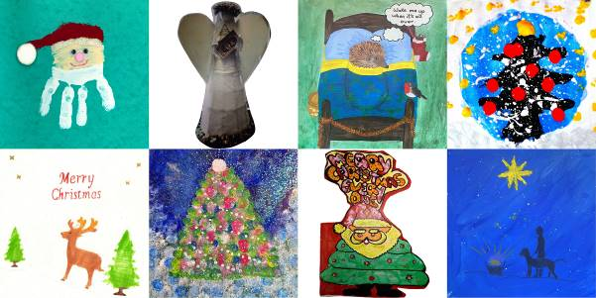

Image: Eight of the Christmas card designs that were submitted for the 2024 Christmas Art Competition.

Top, left to right: a Santa Claus head made out of a handprint a photo of an angel sculpture, a sleepy hedgehog with the text “Wake me up when it’s all over” and a lit up Christmas tree.

Bottom, left to right: a reindeer in trees with the text “Merry Christmas”, a decorated Christmas tree, Santa Saying “Merry Christmas Everyone” a person and a guide dog under a star.

**Children, Young People and Families**

This summer, the Children, Young People and Families Department curated a range of exciting events to bring families together, create lasting memories and build confidence in our young people. We kicked off with Milkshake! Live, where children met their favourite TV characters in an energetic, interactive performance. Our Mobile Planetarium offered a journey through the stars, captivating young minds with the wonders of the cosmos. The Wizard Maze provided a magical adventure, with families solving puzzles and uncovering hidden treasures in an enchanting setting. We also organised a special trip to Pleasurewood Hills, ensuring families enjoyed a day of thrills and laughter at the theme park. These events, designed to engage and inspire, were met with overwhelming enthusiasm, and we’re proud to have made this summer one to remember for our community.

Furthermore, our preschool stay and play sessions continue to convene on the second Monday of the month at our Great Yarmouth Hub and the second and last Wednesday at the Norwich Bradbury Activity Centre, offering parents the chance to connect and access support. We continue to provide the popular one-on-one emotional and practical support for families, offering an essential service to help them understand the impact of vision impairment. Our assistance includes home visits, advice on benefits, grants and funding, along with referrals to various relevant services and organisations.

As we move closer to the festive season, we have an exciting line-up of events to bring joy and holiday cheer. We’re thrilled to announce our upcoming visit to the Norwich Theatre Royal Pantomime, a magical ride on the Christmas Train, and our annual Christmas Party filled with games, music, and a special visit from Santa.

We welcome your input and encourage you to share suggestions for new activities and other ways we can offer support. Please reach out to CYPF@visionnorfolk.org.uk with any questions or ideas.

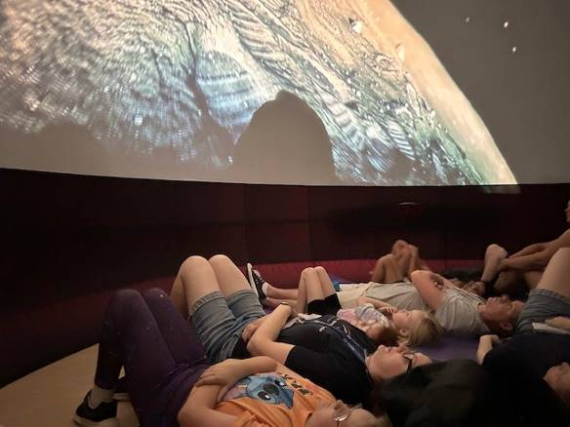

Image: Young people and volunteers laying on the floor looking up at the image of a planet from space.

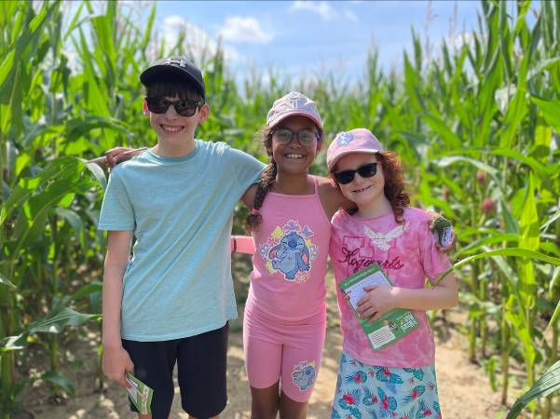

Image: Three young people standing in a corn maze with their arms around each other, smiling at the camera.

**Equipment and Technology**

If you have any questions about daily living equipment we can provide support at our community hubs in Norwich, King’s Lynn and Great Yarmouth or over the phone. Our Community Outreach Workers are also available for home visits where they can discuss which of our services may be of interest to you, including discussing equipment and how your living space can best work for you.

To find out more please get in contact with John at 01603 573000 extension 323.

**Opportunities to Talk About Technology**

Tea and Tech – Norwich, Last Monday of the Month, 1:30pm-3:30pm

Rachael and Darryl Andrews invite you to come along to the Norwich Hub and chat about your tech products. This is not a training session but a discussion session for likeminded people to talk about technology.

If you might be interested please contact Richard at 01603 573000 extension 322.

Technology Training Sessions with RNIB – King’s Lynn, Monthly on a Wednesday (16th October, 13th November, 11th December), 11am-3:45pm

These are one-to-one problem solving sessions with Mohammed Atif, Technology for Life Coordinator at RNIB, to help you with any issues you are having with digital technology and devices. Free 45 minute sessions must be booked ahead of time.

If you might be interested please contact Penny at 01553 660808.

Technology Support Sessions – Great Yarmouth, Last Wednesday of Each Month, 1pm-2pm

One of our volunteers is offering oneto-one help and support to anyone who might be experiencing issues with their technology. Please be aware this will need to be booked in advance.

If you might be interested please contact Catherine at 01493 745973.

**Equipment Tip – Labelling**

This edition we are focusing on different ways that you can create accessible labels to allow for more independence when getting ready in the morning and throughout your day.

Braille can be a great tool for translating the world into a tactile format. Braille labels can be produced using a wide variety of methods and materials. You can use self-adhesive labelling tape in a Braille labeller, a Braille frame or a Perkins Brailler that has been fitted with an adaptor. You can also emboss straight onto self-adhesive, tie-on, magnetic and paper labels using a Perkins Brailler,  Braille embosser or hand frame.

If you don’t read Braille you can also make audio labels. A PenFriend allows you to make an audio label by recording information on a tactile sticker which can then be scanned and read by the device. You can record short or long messages on each label making it perfect for labelling items from music and film collections, to frozen food and 8 items in your kitchen cupboards. It is also possible to purchase washable audio labels that can be attached to clothing and bedding.

There are also number of lower tech labelling systems which many people use either alongside or instead of audio and Braille labels. Tactile labels can be created using bumpons or any tactile sticker. Buttons of different shapes can be sown discretely into clothing to mark different colours. Different numbers of rubber bands can be put around cans of food or around shampoo and condition to easily feel the difference. Rubber bands or pipe cleaners can also be wrapped around doorknobs in hotel rooms to help you identify your room. You can create a system with safety pins to quickly distinguish between different coloured clothing in your closet. For example one pin meaning black, two blue and so on. You are only limited by your creativity and the most important thing is that you find the system that makes your life easier.

**Colour Detection**

When preparing to label clothing another useful tool is a colour detector. If you aren’t able to see colour, or would like a quick confirmation, this device is able to audibly read out colours placed in front of it. The device can also be used to detect the shade of colour to help, for example, to separate laundry into lights and darks for the wash. For smartphone users there are apps such as ColorADD and Color Inspector which allow you to turn your phone into a colour detector. The Be My Eyes App can also be a useful tool if you need to quickly check the colour of a piece of clothing or what is on a label. This app anonymously connects you with a sighted volunteer who can work as a second set of eyes using your device’s camera.

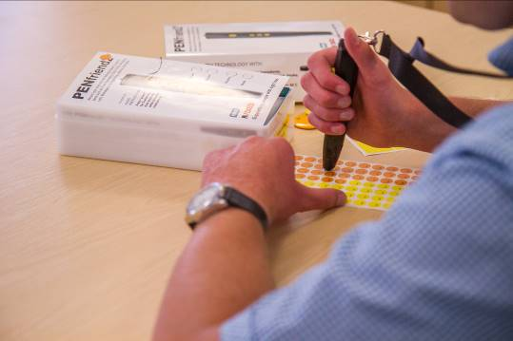

Image: The arms and hands of someone using a PenFriend to record or read audio on small orange and yellow stickers.

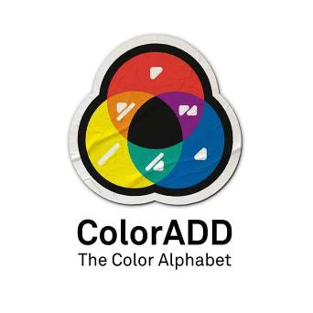

Image: The ColorADD app logo.



Image: The Be My Eyes app logo.

**Norwich Hub Updates**

We have been making the most of the sunshine with outdoor adventures including fortnightly sailing trips and an outing to the Mulbarton Open Gardens Day in July

In the next few months we are looking forward to seasonal events including a Halloween Quiz and Chips and booking holiday events including a trip to see the panto at Norwich Theatre Royal and a Christmas choir performance at The Hub. Please check out the full list of events and activities in the next section.

**The Great Vision Norfolk Bake Off**

Paige Simonds has carried off the inaugural ‘Vision Norfolk Bake Off’ prize. She won the prize for a stunning Bakewell Tart in the competition, which was the culmination of the Norwich cooking course designed to help those living with sight loss to cook independently.

A dozen people with varying degrees of sight loss have been learning to cook using a range of specialised gadgets such as talking scales and talking air fryers. The group has learned how to make a variety of dishes including curries, pasta dishes, pizzas, cakes and bread with lessons taught by Community Outreach Worker Sue Warnes.

“The cookery course is all about giving people the confidence to live independently,” said Sue. “We introduce a range of special gadgets to help vision impaired people in the kitchen, and focus on dishes which people can easily recreate in their own home.

“Being able to create meals for yourself is a key skill in maintaining independence, and we plan to offer more cookery classes in the coming weeks and months.”

The Bake Off competition was run to enable participants to showcase their newly-acquired skills, with a variety of savoury and sweet bakes.

Paige had never picked up a spatula before the course. She moved into her Hammond Court supported living accommodation in January and realised she needed to learn to cook for herself.

“I had never cooked before, so starting to live independently was daunting for me,” said Paige. “The cookery classes have really given me confidence, and I now enjoy cooking in my flat.”

**Calling All Theatre Lovers**

We will be running more outings to some of the Norwich Theatre Royal’s audio described performances.

Next up we will be heading to Aladdin, the 2024 Panto at Norwich Theatre Royal on Monday 30th December. Follow Aladdin as he dreams of finding love and making his fortune. The performance starts at 2.30pm and should finish around 5pm. A touch tour will happen before the performance but the time is yet to be confirmed. Please let us know as soon as possible if you are interested in joining us.

We are also running trips to the audio described of An Inspector Calls on Wednesday 22nd January and Chicago on Saturday 19th July.

Please contact Mark for more details on 01603 573000 extension 341.

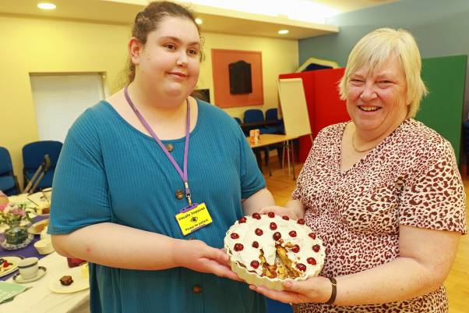

Image: Vision Norfolk Bake Off winner Paige Simmonds (left) and judge Karen Norton holding the winning tart between them.

**Norwich and South Norfolk Activities**

Unless otherwise stated please contact Richard at 01603 573000 extension 322 or richard.polley@visionnorfolk.org.uk.

**Special Events**

Cancer Awareness Session – Norwich, 11th October, From 1pm

The Cancer Awareness Team from The Big C Cancer Charity will be giving a talk at the Norwich Hub about cancer symptoms and what to look out for. All are welcome. The talk will be right between meetings of the macular and glaucoma support groups and we encourage interested people to come along to those meetings.

Halloween Quiz and Chips – Norwich, 31st October, 2pm-3:30pm

Test your trivia knowledge against our other community hubs at the Halloween Quiz and Chips. There will be a prize for the best fancy dress. Chips cost £2.50 per portion. Please let us know you’re coming by 25th October.

Christmas Carol – Norwich, 11th December, arrive from 2pm

Join us for a Christmas Carol Service conducted by the Reverend Heather Wright followed by light refreshments. Please let us know if you would like the order of service and carols in large print or Braille. Please notify us by the end of November if you will be attending.

Theatre Trip: Aladdin Panto – Norwich, 30th December, 2:30pm-5pm

Join Vision Norfolk for an audio described performance of Aladdin the 2024 pantomime at Norwich Theatre Royal. Tickets cost £40 including a sighted guide if required. To book your ticket call Mark on 01603 573000 extension 341.

**Regular Activities**

Arts and Crafts – Norwich, Every Thursday 10am-12:30pm

Undertake a variety of arts and crafts with support from Helen and the volunteers. Contact Helen on 01603 573000 extension 342.

Audiobook Clubs

Our friendly, informal audiobook clubs offer a chance to get together and enjoy a chat about a chosen book. The book clubs are free to join and we can supply a memory stick player if you don’t have one. Contact Mark on 01603 573000 extension 341.

Diss Audiobook Club – 4th Friday of the Month, 2pm-3:30pm

Norwich Audiobook Club – 2nd Monday of the Month, 1:30pm-3pm

Boccia – Norwich, 1st and 3rd Friday of the Month, 10am-12pm

Join us for the competitive precision ball sport boccia. Sessions are open to all abilities and levels of experience.

Bowling – Norwich, 2nd and 4th Friday of the Month, 9:30am-1pm

Come and enjoy some friendly competition with ten pin bowling at Namco Funscape. Transportation available from the Norwich Hub. Regular bowling fee to be paid to Namco Funscape.

Braille Classes – Norwich, Every Thursday, By Appointment

Join our Braille class taught by one of our volunteers. The classes are small, usually on a one-to-one or one-to-two basis.

Coffee Mornings and Socials

Come and enjoy a cup of coffee and a chat at one of our socials.

Attleborough Drop-in Cafe – Fortnightly from 23rd September, 11am-12:30pm, contact Chris Linstead at 07743 921430

Norwich Coffee Morning – Last Monday of the Month, 10am-11:30am

Norwich Drop-in Café – Fortnightly from 18th September, 11am-12pm

Taking place at Plumstead Road Library. Contact Jo at 01603 573000 extension 454.

Thetford Drop-in Café – 4th Wednesday of the Month, 2pm-3:30pm, contact Chris Linstead at 07743 921430

Cooking with Sue – Norwich, Monthly on a Thursday (26th September, 24th October, 21st November, 19th December), 2pm-4pm

Each month we will be running a cookery lesson at our Norwich Hub teaching practical skills that can be used at home.

Creative Writing – Norwich, 3rd Tuesday of the Month, 2pm-3:45pm

Join a creative writing group that will give you the opportunity to express yourself through the written word. Contact Mark on 01603 573000 extension 341.

Darts – Norwich, 1st and 3rd Friday of the Month, 1pm-3pm

Join us for a few friendly games of darts. Volunteers are around to help you position or read the numbers on the board if needed.

Glaucoma Support Group - Norwich, 2nd Friday of the Month, 2pm-3:30pm

A self-help and discussion session for local people living with Glaucoma created in partnership with Glaucoma UK. We sometimes have speakers in to talk about Glaucoma and other subjects.

Macular Group – Norwich, 2nd Friday of the Month, 12pm-1:30pm

This group is organised and run by the Macular Society. Vision Norfolk staff usually give an update on new equipment and activities and there are sometimes guest speakers.

Photography Group – Norwich, 1st and 3rd Friday of the Month, 1:30pm-3:30pm

The first meeting in each month is an outdoor photoshoot and the second is an indoor opportunity to review photographs. Some outings may have a cost for refreshments. Contact Mark on 01603 573000 extension 341.

Sailing – Norwich, Fortnightly from 12th September, 12:30pm-5pm

Come and enjoy an afternoon of sailing on the Norfolk Broads. Trips cost £18 per person. Starting in November we will be switching to a monthly trip on a covered motor cruiser during the cooler months. Contact Mark at 01603 573000 extension 341.

Short Mat Bowls – Norwich, Every Tuesday, 10am-12pm

Come and enjoy some friendly competition with the traditional British game short mat bowls.

Tandem Cycling – Norwich, By Appointment

Tandem cycling allows you to continue to enjoy a good (and safe) bike ride regardless of your vision loss. A sighted guide sits at the front to steer and describe. Sessions are subject to volunteer availability and weather.

Tennis – Norwich, Fortnightly from 20th September

Join tennis sessions designed for people living with sight loss. The sessions are at Waterloo Park and will be weather dependent. Contact Mark at 01603 573000 extension 341.

Yoga – Norwich, Every Tuesday, 1pm2pm and 2:15pm-3:15pm

Come stretch and relax with yoga. Sessions are designed to be accessible to all abilities and levels of experience. We have spaces available in both the seated and advanced yoga sessions.

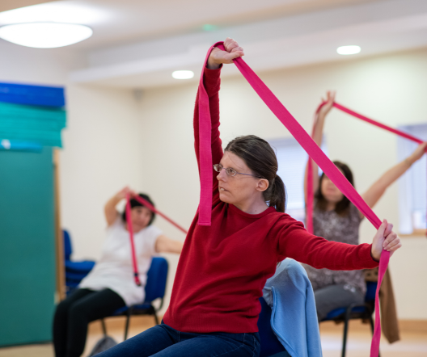

Image: Three seated women stretching with a resistance band at a yoga session.

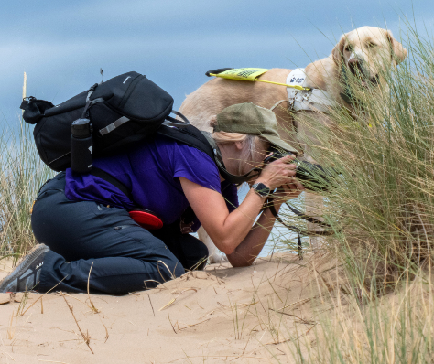

Image: A woman kneeling to take a picture of a beach plant while her guide dog stands behind her at a photography group meeting.

**King’s Lynn Hub Updates**

**We’re moving!**

We are moving to a new location at 20 Thoresby College, Queen Street, King’s Lynn, PE30 1HX.

Thoresby College is a lovely listed property which was originally built in the 16th century to provide accommodation for 13 priests employed as chantry chaplains by the Trinity Guild of Lynn. After the Reformation the college was sold and subsequently underwent adaption for domestic and commercial use.

The new community hub will be about 10 minutes’ walk from the main bus and train stations in King’s Lynn. We are very excited to be located right in the centre of town and hope this will allow people who use public transportation to access the hub more easily. Unfortunately there isn’t parking available at the new building however there are a number of carparks nearby including Saturday Market Place, Baker Lane and St James Court, all of which are within a five minutes’ walk.

At the time of writing this newsletter we are in the process packing everything up and getting the new hub ready. We are planning to be in the new hub by mid-September. All the regular activities that take place at the hub will be at the new location from that point on.

Please get in contact if you have any questions or concerns.

**Art Workshops – What We’ve Been up to…**

We hold small art workshops on the first Friday of each month. Each workshop focuses on a different skills and materials. Over the summer participants have been creating unique works of art with painting, glass painting, mosaics, finger painting and more. Creations include the Scream witch and painted bottle picture above.

We have some spaces left at the regular art workshops if you think you may be interested in coming and giving it a go.

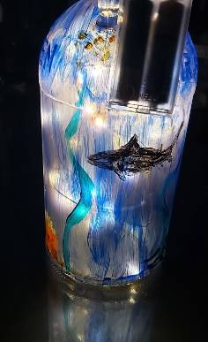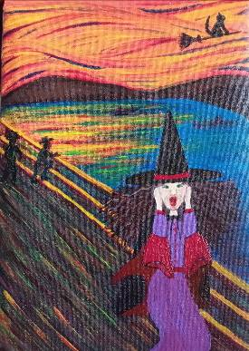

Image (Left) – A bottle painted with an underwater scene lit with fairy lights from the inside.

Image (Right) – A painting recreating the famous “Scream” painting by Edvard Munch with a witch replacing the main figure.

**We are looking for more singers!**

We are looking for singers to join the Sound and Vision Choir which takes place fortnight on Wednesdays from 1pm until 3pm at The Workshop in King’s Lynn.

Improve your mental wellbeing, learn new things, meet new people, enjoy being creative and most importantly have fun! We’re a very casual social group. No previous singing experience necessary.

This activity is run in partnership with The Workshop, a centre for performing arts located in King’s Lynn.

**As Seen on ITV**

We had some guests from IVT News Anglia visit at a special archery session to talk to participants about their experience with archery and sight loss. The news piece was part of their coverage of preparation for the Paralympic Archery event on the evening news on Monday 19th August. You can watch the news piece online on ITV News Catch-up with the story running from 15:40 until 19:11.

**West Norfolk Activities**

Unless otherwise stated contact Abbi at 01553 660808 or kingslynnhub@visionnorfolk.org.uk.

Please be aware that any activities that take place at the King’s Lynn Hub will now be taking place at our new community hub at 20 Thoresby College, Queen Street, King’s Lynn, Norfolk, PE30 1HX. If you are unsure where an occurrence of a regular activity will be taking place please get in contact.

**Special Events**

Halloween Quiz and Chips – King’s Lynn, 31st October, 2pm-3:30pm

Test your trivia knowledge against our other community hubs at the Halloween Quiz and Chips. Fancy dress encouraged.

Please let us know you’re coming so we can plan the chips order. Chips costs £2.50 per portion.

Christmas Craft Day – King’s Lynn, 14th November, 11am-2pm

Pop in and help us create the homemade decorations which will make our Hub a Christmas wonderland! Crafts for all skills levels will be available and help can be provided where needed.

Christmas Celebration – Tuesday 17th December, 10am – 12pm

Our last coffee morning before Christmas will be our big festive celebration for clients and volunteers. Expect cheesy Christmas music, Santa hats and mince pies.

**Regular Activities**

Archery

Join one of our archery sessions designed to be accessible for all abilities and skill levels.

Downham Market Archery - 1st Monday of the Month, 4pm-6pm

Fakenham Archery – 4th Wednesday of the Month, 2pm-4pm

Art Workshops – King’s Lynn, 1st Friday of the Month, 1pm-3pm

We are hold regular small art workshops with painting, print making, collage and more. Free to attend and no prior experience necessary.

Audiobook Clubs

Our friendly, informal audiobook clubs offer a chance to get together and enjoy a chat about a chosen book. The book clubs are free and we can supply a memory stick player. Contact Mark on 01603 573000 extension 341.

Dereham Audiobook Club – 3rd Wednesday of the Month, 10:30am12pm

Fakenham Audiobook Club - 3rd Monday of the Month, 10:30am-12pm

Gaywood Audiobook Club – 1st Thursday of the Month, 2pm-3:30pm

Coffee Mornings and Socials

Come and enjoy a cup of coffee, a slice of cake and a chat about everything and anything at one of our socials.

Downham Market Social – 4th Wednesday of the Month, 11am-1pm

Fakenham Coffee Morning – 4th Tuesday of the Month, 10am-12pm

King’s Lynn Coffee Morning – 1st and 3rd Tuesday of the Month, 10am-12pm

King’s Lynn Drop-in Café – 3rd Wednesday of the Month, 11am-1pm.

Now at The Lattice House, Chapel St, King’s Lynn PE30 1EG

Swaffam Drop-in Café – 3rd Thursday of the Month, 10am-12pm

Cooking – King’s Lynn, 2nd Friday of the Month, 10am-12pm

Each month we will be running a cookery lesson at our King’s Lynn Hub teaching practical skill that can be used at home.

Darts and Shuffleboard – King’s Lynn, 4th Thursday of the Month, 10am-12pm

Come and enjoy your choice of darts or shuffleboard with assistance and competition available as needed.

Knitting – King’s Lynn, 2nd Tuesday of the Month, 1:30pm-3:30pm

Whether you are a complete beginner who would like to take up knitting or a seasoned knitter, our sessions are a fun and sociable way of getting together with fellow yarn fans.

Pub Club – Varies Locations, 2nd Monday of the Month, 12pm-2pm

A relaxed and friendly group that meet for a chat over lunch at local pubs. The group is free to attend but some special activities and outings are paid for by participants directly.

Short Mat Bowls – Fakenham, 1st Friday of the Month, 2pm-4pm

Come and enjoy some friendly competition with the traditional British game short mat bowls.

Sit Fit – Downham Market, 3rd Friday of the Month, 1:30pm-3:30pm

A seated exercise class suitable for all adults regardless of age, gender or ability. This dynamic class will have your legs and arms moving and is fully adaptable to all abilities.

Sound and Vision Choir – King’s Lynn, Fortnightly from 12th June, 1pm-3pm

Join the Sound and Vision Choir to improve your mental wellbeing, meet new people and most importantly have fun. The choir is run in partnership with The Workshop in King’s Lynn.

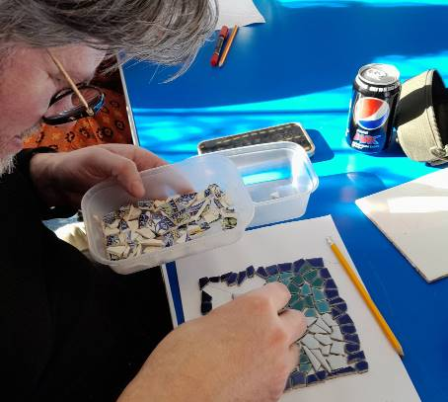

Image: A man leaning over a mosaics art piece placing small coloured pieces.

**Great Yarmouth Hub Updates**

We have had a very busy few months, and have enjoyed getting out and about to a variety of different places.

**Railway and Water Cruise**

A group of local people with sight loss joined Vision Norfolk for a day out in the countryside with a train trip and water cruise. The day started with a lovely train ride on Bure Valley Railway along the nine mile track from Wroxham, before stopping to enjoy lunch at the Whistlestop Café at Aylsham Station prior to the return journey.

In the afternoon the group embarked on the Southern Comfort at Horning for a special audio described trip on the Norfolk Broads.

**Alpaca Trekking**

We have also enjoyed a trip out to visit and walk some alpacas in June with an Alpaca Trekking excursion near Wellsnext-the-Sea. The pleasant weather made for an ideal outing, allowing participants to stroll, chat, and introduce the alpacas to curious onlookers. Everyone received a keyring as a memento of their alpaca companion.

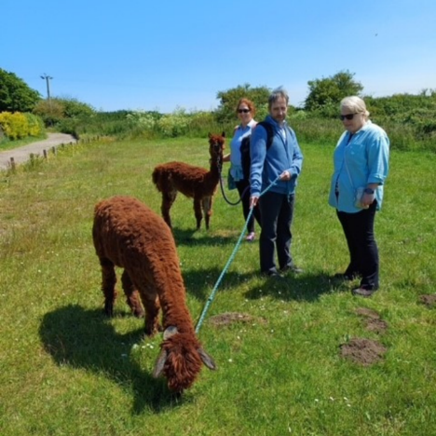

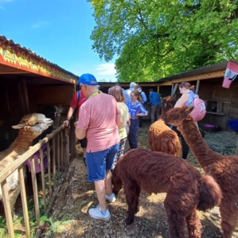

Image (Left): A group of people standing by the alpaca pens greeting the animals. Three alpacas are already standing with the group.

Image (Right): three people standing with two alpacas on leashes in a green field.

**Other Outings**

We’ve also had plenty of seafront walks, as well as some local walks with Pathmakers, plus tennis at Gorleston Tennis Club and some fun activities in the hub.

Recently a group took part in a pottery making workshop with Clare from Wayside Pottery. Rebecca from Dandelion Mosaics came and ran another successful workshop. We’ve also enjoyed new rug making sessions which are very popular, as well as our regular activities including Fishy Friday, games, weaving and the Great Yarmouth Coffee Morning.

**New Activities**

**Creative Writing**

Ever considered taking up writing? The Great Yarmouth hub has started a creative writing group. Sessions run monthly on a Friday between 1pm and 3pm, but please contact us as dates may vary. We hope to cover a variety of different subjects, and all formats are accepted. No experience necessary.

**New Client Drop-in**

If you are curious to see what we do, but haven’t yet got into the hub, we are holding new client and volunteer drop-in sessions at St George’s Theatre Cafe. Sessions will take place on the last Monday of the month between 1:30pm and 3:30pm.

**Yoga**

We are pleased to announce that we are starting a new yoga session from October. We are working with Georgina Huggins, a yoga therapist and teacher. No experience is required, sessions will start on 2nd October, and then from November, we will have two sessions a month. Times and dates will vary, so please speak to us for more information.

**East Norfolk Activities**

Unless otherwise stated please contact Catherine at 01493 745973 or greatyarmouthhub@visionnorfolk.org.uk.

**Special Events**

Tea Dance – Great Yarmouth, 16th October, 2pm-4pm

Join us at the Great Yarmouth Town Hall for an afternoon of dancing. Please get in contact for more information.

Bingo and Burgers – Great Yarmouth, 22nd October

Come in for a game of bingo and a burger. Please let us know if you’re interested in coming. We are asking for £1 each for the burgers.

Halloween Quiz and Cake – Great Yarmouth, 31st October, 2pm-3:30pm

Test your trivia knowledge against our other community hubs at the Halloween Quiz and Chips. Please let us know you’re coming so we can plan the refreshments. We are asking for £1 per person to cover the cake.

**Regular Activities**

Audiobook Clubs

Our friendly, informal audiobook clubs offer a chance to get together and enjoy a chat about a chosen book. The book clubs are free to join and we can supply a memory stick player if you don’t have one. Contact Mark on 01603 573000 Extension 341.

Cromer Audiobook Club – 3rd Monday of the Month, 2pm-3:30pm

Great Yarmouth Audiobook Club – Last Friday of the Month, 1:30pm-3pm

Bowling – Great Yarmouth, 29th October, 12pm-3pm

We run group bowling trips to Wellington Pier on alternative months.

Clip and Climb – Great Yarmouth, 26th November, 3pm-4pm

Ever fancied rock climbing? Clip n’ Climb is made up of a number of unique climbing elements at the indoor climbing gym at the Great Yarmouth Marina Centre. Trips are run on alternate months.

Coffee Mornings and Socials

Come and enjoy a cup of coffee, a slice of cake and a chat about everything and anything at one of our socials.

Cromer Coffee Morning – Last Wednesday of the Month, 10am-1pm, Contact Karl at 07864 615929

Great Yarmouth Coffee Morning – Every Wednesday, 10am-12pm

Martham Coffee Morning (and Snooker) – 3rd Monday of the Month, 10am-12pm, Contact Matthew at 01603 573000 extension 455

Creative Writing – Great Yarmouth, Monthly on a Friday, 1pm-3pm

We have started a new Creative Writing Group! We hope to cover a variety of different subjects, and all formats are accepted. No experience is necessary, just come and have a go.

Fishy Friday – Great Yarmouth, 1st Friday of the Month, 1pm-2pm

Meet other local people living with sight loss and have a chat over fish and chips. Costs £6.50 per person to cover the food.

Games Morning – Great Yarmouth, Every Thursday, 10am-12pm

Join our fun and welcoming games mornings to try out cards, bingo, dominoes and floor and table games.

Knit and Natter – Great Yarmouth, 2nd Thursday of the Month, 1pm-2pm

Join Norfolk Knitters at our group where we learn together how to knit along with having a good natter and chance to meet new people.

New Client Drop In Sessions – Great Yarmouth, Last Monday of the Month, 1:30pm-3:30pm

If you are curious to see what we do, but haven’t yet got into the hub, we are holding new client and volunteer drop-in sessions at St George’s Theatre Cafe.

Life Skills – Great Yarmouth, 2nd Monday of the Month, 2pm-4pm

Each month we will be running a cookery lesson at the Great Yarmouth Hub. Sessions will introduce adaptive technology and teach practical skills designed to be transferable to your home kitchen.

Rug Workshops – Great Yarmouth, Last Friday of the Month, 10am-12pm

Join experts from local business Ruskin’s Rugs at the Great Yarmouth Hub. Use their rug making kits to make your own rugs and wall hangings.

Seafront Walks – Great Yarmouth, Last Thursday of the Month, 1pm-3pm

Join us for a breath of fresh air and a leisurely stroll along the one of our many local seafronts including a stop for refreshments along the way.

Tennis – Gorleston, 2nd Tuesday of the Month, 10:30am-12pm

Give tennis a try at special sessions led by LTA-accredited coach Mike Reynolds.

Weaving Group – Great Yarmouth, Every Friday, 10am-12pm

Use different types of soaked cane to make baskets of all shapes and sizes. Please note the last Friday of each month weaving will be replaced with Rug Workshops.

Yoga – Great Yarmouth, 2nd October and then around fortnightly

We are pleased to announce that we are starting a new yoga session from October with Georgina Huggins, a yoga therapist and teacher. No experience is required. Please get in contact for more details as dates are still being confirmed.

**Useful Information**

Nimbus Access Card

The Access Card is created by disability social enterprise Nimbus and therefore is sometimes referred to as the Nimbus Card. It is a disability identification card designed to easily communicate and verify your access requirements for a variety of events and venues.

The card is the same size as a regular credit card and shows your photograph, your card number and a series of small symbols to represent your needs. When applying for the card you are required to show relevant evidence of your needs. Therefore the card acts to both communicate the type of adaptations you require and minimise your need to carry extra paperwork. The card can be presented either in person at the venue or the number can be used online when booking tickets.

It currently cost £15 for 3 years. The application is available online or in by mail. As part of the application you will have to upload or post the required proof of your disability, benefit status and a photograph. If you struggle to complete the form the help desk can assist over the phone but all documents of proof would still need to be forwarded to them.

The Access Card is not currently accepted as proof of disability at all venues however their list of partner providers has been steadily growing since the card was first made available in 2016. Some local venues that are listed as Access Card providers include: Norwich Theatre, many major local cinemas, The Waterfront, Hollywood Bowl, The Sundown Festival and many others.

More information and a full list of partner providers can be found on the Access Card website at www.accesscard.online or you can call the Access Card team at 0330 808 5108.

**Blind Person’s Tax Allowance**

You can claim Blind Person’s Allowance if you can prove you’re registered with your local council as blind or severely sight impaired.

Blind Person’s Allowance is an extra amount of tax-free allowance. It is added to your tax-free Personal Allowance and increases the amount of income you can have each year before you start paying tax. The Blind Person’s Allowance for the tax year 2024-25 is £3,070, regardless of your age or income.

You have to claim the Blind Person’s Allowance – it won’t be given to you automatically. Claims can be backdated by up to four tax years, so if you can prove you were registered blind or severely sight impaired in or before the 2020-21 tax year you could benefit by up to £2,588 if you pay tax at the basic rate of 20%.

You can transfer the Blind Person’s Allowance, or the unused part of it, to your spouse or civil partner if you don’t pay tax or can’t use all of it. This can be done whether or not they are blind. If both you and your spouse or civil partner qualify for Blind Person’s Allowance you can claim an allowance each.

**Contact Details**

Phone: 01603 573000

Email: office@visionnorfolk.org.uk

Norwich

Bradbury Activity Centre, Beckham Place, Edward Street

Norwich, NR3 3DZ

Phone: 01603 573000

office@visionnorfolk.org.uk

King’s Lynn

20 Thoresby College, Queen Street

King’s Lynn, PE30 1HX

Phone: 01553 660808

Email: kingslynnhub@visionnorfolk.org.uk

Great Yarmouth

12 Hall Quay

Great Yarmouth, NR30 1HP

Phone: 01493 745973

Email: greatyarmouthhub@visionnorfolk.org.uk

Registered Charity No. 1206599