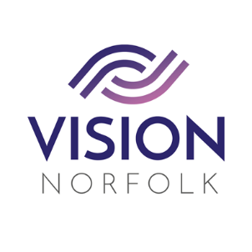

Role Title: | Befriending Volunteer
Hours and Location: | To be agreed upon completion of training
About the organisation: | Vision Norfolk’s mission is to support people living with sight loss to live active, independent and fulfilled lives.
About the role: | We are looking for volunteers to support our Community Outreach Workers in an exciting new role. As a befriender you will be matched with one of our clients and will visit them in their home or out in the community, in a social capacity. Befrienders play a valuable role in providing company and social interaction and easing loneliness.  This is a purely social role, you will not be required to perform any personal or medical care for you befriendee.
Skills / Experience needed: | - Our volunteers must be caring, able to communicate well and enjoy meeting new people, whilst helping our clients to remain as independent as possible.  - Experience of supporting people on a one to one basis would be advantageous but not essential  - Talk to / listen to our clients and make them feel comfortable in your company.
Benefits of Volunteering in this role: | Becoming a volunteer is a wonderful opportunity to make a difference and support your local community. Vision Norfolk also offers:  - Regular advice, support, and training  - Payment of out of pocket expenses agreed in advance
Contact details: | To discuss this role or other opportunities please contact the Volunteer Engagement Coordinators on 01603 573000 or volunteers@visionnorfolk.org.uk. We also have application forms available on our website: www.visionnorfolk.org.uk

