**Vision Norfolk**

**Annual Review 2023/24**

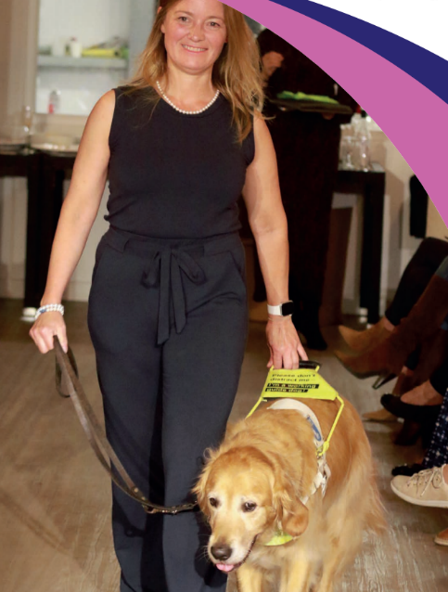

Front Cover Image: Blind model Lana Hempsall and her guide dog Zorin take to the catwalk at a charity fashion show at Chet Valley Vineyard to raise funds for Vision Norfolk

**Chair’s Message**

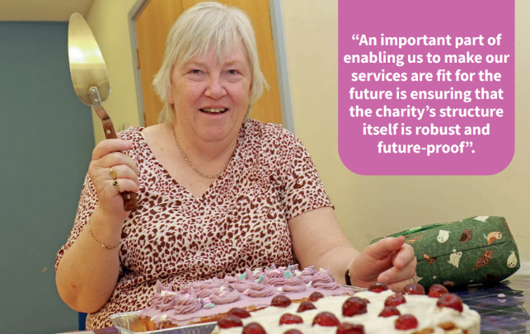

Image: Vision Norfolk Chair of Trustees Karen Norton judging the inaugural ‘Norfolk Vision Impaired Bake Off’ earlier this year. Pull quote “An important part of enabling us to make our services are fit for the future is ensuring that the charity’s structure itself is robust and future-proof”.

As we review another 12 months of Vision Norfolk, I am delighted to report that the year has seen the charity expand the services we offer to vision impaired people throughout Norfolk, helping us achieve our goal of reaching out to more people in the county whose lives we can enhance with the support we provide.

During the pandemic we made the difficult decision to pause our community outreach programme. The restrictions on our activity, coupled with the squeeze on fundraising which every charity experienced, meant that it was simply not possible to continue with this service. At the time we made it clear that we would re-introduce community-based support just as soon as circumstances allowed.

I am delighted to report that 2023/24 saw us do just that, with the introduction of a new team of community outreach workers. Taking our services and support out into the community and to vision impaired people living in their own homes is a vital part of increasing the impact of the work that Vision Norfolk does.

Our community outreach team completed 1,069 home visits between July 2023 (when the service was introduced) and March 2024. Alongside these visits, the team has greatly enhanced the range of activities and events which we are able to offer, including the wildly popular ‘Cooking With Sue’ initiative, which culminated in our first ever Norfolk Vision Impaired Bake Off, at which I was honoured to be a judge.

An important part of enabling us to make our services are fit for the future is ensuring that the charity’s structure itself is robust and future-proof. After several years’ preparation, this year saw Vision Norfolk become a Charitable Incorporated Institution, a structure which reflects the professional nature of the charity, and which will enable us to modernise the way we deliver services. Although this is an important move in terms of governance, users and staff will not notice any significant difference to the support they receive.

Last year I reported the launch of an extensive programme to significantly upgrade the 20 flats in Hammond Court, including expanding 13 bedsit studios into one-bedroom flats, installing new adapted kitchens and bathrooms, and adding patio doors in every flat. The second phase of this programme was launched during 2023/24, covering the refurbishment of the flats in Hammond Court 2. By the time you read these words, the whole refurbishment project will have been completed.

Our community hubs in Great Yarmouth, Norwich and King’s Lynn are an important part of our provision. We have been aware for some time that our King’s Lynn hub, situated on a business park to the north of the town, was not ideal, both in terms of location and the building itself.

During the year we took advantage of a break clause in our lease to seek a new building from which to offer our services, and we were fortunate to find suitable accommodation in the town centre. We have been working hard to refurbish this building – with the generous help of various local businesses – and the new hub opens in September 2024.

Much of the support we provide to vision impaired people in the county is only possible because of the amazing support provided by our army of volunteers – their contribution is acknowledged separately in this report. We are so grateful to every one of them, and I encourage anyone considering becoming a volunteer to come forward and discover just how rewarding and fun being a volunteer can be.

Finally, I would like to thank everyone who has worked so hard to put the charity in the strong position it finds itself in as we close our 218th year. That includes, staff, trustees, volunteers, fundraisers, funders and donors, and of course our wonderful clients whose resolute cheerfulness and determination makes it all worthwhile.

*Karen Norton, Chair of the Trustees.*

**Chief Executive’s Message**

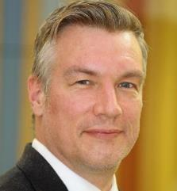

Image: Andrew Morter

In last year’s annual review I reported a year of consolidation for Vision Norfolk, laying foundations for the future growth; the year 2023/24 saw a period of strategic growth and resilience for the charity. With our leadership team and five year strategy firmly in place, we have focused on increasing the reach and impact of our services while addressing the challenges of financial sustainability.

Our main focus during the year was on growth and financial sustainability. The trustees and senior leadership team have been diligently working on our strategic plan to address our operational deficit by 2030. This involves an ambitious plan to diversify our income streams, recognising the challenges posed by increasingly competitive trust and grant funding, and the difficulties of fundraising amidst a cost of living crisis.

But perhaps our most important achievement in the year was a significant increase in client engagement across all our services and activities. We have now embarked on a five year strategy to ensure that we are providing the services which really meet the needs of vision impaired people across the count, and one of the main measures of how successful we are in delivering that strategy will be reaching more of the 38,000 people living with sight loss in Norfolk.

Our Eye Clinic Liaison Officers (ECLOs), who offer practical and emotional support in each of the eye clinics across the county, helped over 500 patients understand their specific eye condition at the point of diagnosis and treatment, as well as helping them navigate the different types of support available to them both from Vision Norfolk and other community-based services.

Between its launch in July 2023 and the end of the reporting period in March 2024, our new Community Outreach Service helped over 1,000 people either at home or in their local community, providing practical and emotional support to help build their confidence, skills, and personal resilience to live independently.

In addition to the one-to-one support, our Community Outreach Workers have also set-up a range of events and activities in their local communities as a way of combatting isolation and enabling peer-to-peer support to people through sharing their own experiences of living with sight loss.

Nearly 350 people have been supported by our Equipment Centres with accessing the latest technology and equipment available to help them navigate the complexities and challenges of completing basic day-to-day tasks.

Our social and leisure programme recorded over 2,500 individual attendances throughout the year, across a massive range of activities, specifically designed to promote physical and mental wellbeing, increase confidence and social interaction, and reduce instances of social isolation and loneliness. You will find photos of some of these later in this document.

Our Children, Young People and Families Service has supported over 200 families over the past 12 months, providing both support to the parents of vision impaired children and a range of fun activities for the children to take part in. More details of this aspect of what Vision Norfolk does can be found on page 8 of this review.

Importantly, we continue to strengthen our partnerships within the community. This includes maintaining maintain close working relationships with statutory partners in health and social services, and with Norfolk County Council’s Sensory Support Unit and Virtual School Sensory Support Team. Our collaborations with voluntary partners, including Guide Dogs, RNIB, and Age UK, remain strong and productive.

But while we have made significant strides forward this year, we continue to face many challenges. Traditional funding sources remain under pressure, and we are actively working on strategies to diversify our income streams and improve operational efficiencies. And with social services provision increasingly stretched, we are having to work hard to ensure the safety and welfare of both our tenants and staff in our supported housing provision.

Despite these challenges, the past 12 months has seen a stable foundation laid for the future. In the coming years, our focus remains on achievable and sustainable growth. We are optimistic about facing our challenges head-on, confident that through a combination of creative income generation strategies and operational efficiencies, we can address our deficit over time.

We will be investing in both our fundraising and marketing and communications to ensure that we maximise and diversify and can clearly communicate the numerous benefits we can bring through our work to individuals and wider society. We will also actively seek to gain a better understanding of what the needs and wants are for our communities to ensure that we design and deliver appropriate services to meet these demands.

Our achievements this year would not have been possible without the dedication and hard work of our trustees, staff, and volunteers. We also extend our heartfelt thanks to our supporters, whose continued backing enables us to pursue our mission of supporting vision impaired individuals across our communities.

*Andrew Morter, Chief Executive*

**Looking To The Future**

2025 will mark the 220th anniversary of the founding of the Norwich Institution for the Blind, which is the charity which is known today as Vision Norfolk. As we look to the future, our commitment to being a user-led organisation remains steadfast.

Our primary focus in the coming period will be to gain a deeper understanding of the needs we are not currently meeting for those who are not engaged with our services. This insight will be crucial in shaping our strategic planning for future service delivery, ensuring that we can extend our reach and impact to a wider portion of the vision impaired community in Norfolk whilst managing our costs more effectively.

Our five year strategy, ‘A Shared Vision’, emphasises four main areas:

1. Increasing the reach and impact of our services:

* Conducting comprehensive needs assessments to identify gaps in our current service provision
* Developing innovative outreach programs to engage with previously unreached individuals
* Ensuring that service users' voices remain at the heart of our decision-making processes

2. Investing in our workforce and organisational capacity:

* Enhancing our ability to deliver services at scale while maintaining quality and a person-centred approach
* Fostering a positive workplace culture that attracts and retains talented staff and volunteers

3. Improving financial strength and resilience:

* Investing heavily in our fundraising activities to diversify and strengthen our income streams
* Exploring new and innovative funding models, including social enterprise opportunities and strategic partnerships
* Developing a robust plan to address our operational deficit by 2030, balancing growth with financial sustainability

4. Increasing awareness and building partnerships:

* Raising our profile as a leader in both the sight loss sector and the wider VCFSE sector
* Strengthening existing partnerships and forging new collaborations to extend our reach and enhance our service offerings
* Advocating for the needs of vision impaired individuals at local and national levels

As we embark on this ambitious journey of growth and increased impact, we remain dedicated to being responsive, user-led, and focused on improving the lives of vision impaired people in Norfolk. We are confident that by expanding our reach, strengthening our financial foundation, and continually adapting to meet the evolving needs of our community, we can make a significant difference in the lives of many more individuals living with vision impairment in our region.

**Vision Norfolk was honoured by the announcement that His Majesty King Charles is to be the charity’s new Patron.**

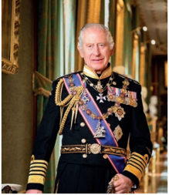

*Image: HM King Charles*

We enjoyed the patronage of Her Majesty Queen Elizabeth for many years, and we were delighted when Vision Norfolk was one of a number of charities and organisations across the country which received the patronage of the King on the occasion of his first anniversary of his coronation earlier this year.

A statement from Buckingham Palace said, “Royal Patronage highlights the vital work of these organisations and allows their many achievements and valuable contributions to society to be more widely recognised and promoted.”

The late Queen visited Vision Norfolk – then called Norfolk & Norwich Association for the Blind – in 2010 to open our Bradbury Activity Centre in Norwich.

**Facts & Figures**

* 509: patients supported by our Eye Clinic Liaison Officers in the county’s eye clinics
* 1,069: interventions by our Community Outreach Service for vision impaired people in their home or local community
* 291**:** support calls made by Vision Norfolk staff to vision impaired people in the county
* 3,648**:** calls made by volunteers via our Telefriends service during the year
* 349: people helped with access to equipment and technology in our Equipment Centres
* 80**:** parents benefitted from virtual support and social sessions
* 222:families attended events in the Children, Young People & Families programme
* 62**:** referrals received for children newly diagnosed with sight loss
* 1,043**:** new referrals received for adults newly-diagnosed with sight loss
* 814: activity sessions completed during the year, including
  + audio book clubs
  + cookery lessons
  + heritage group
  + theatre visits
  + coffee mornings
  + sports including yoga, archery, boccia and darts
  + arts and crafts including pottery, weaving, art and photography
  + creative writing
  + games mornings
  + walks and rambles
* 2,518: people took part in activity sessions

**Supporting Young Families**

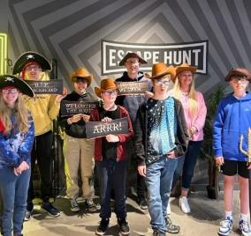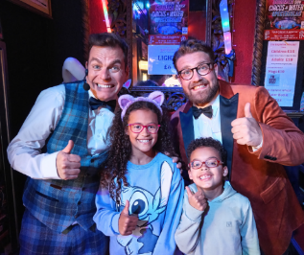

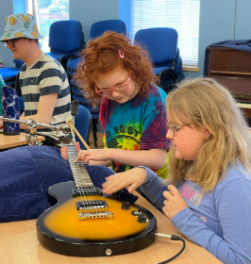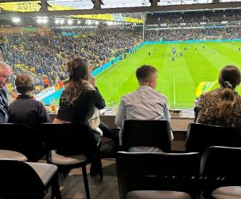

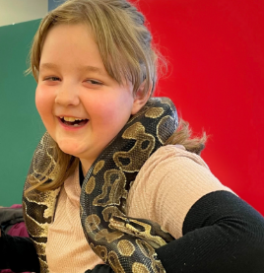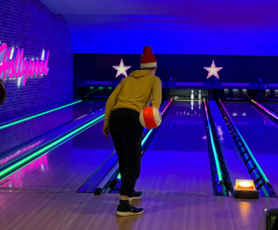

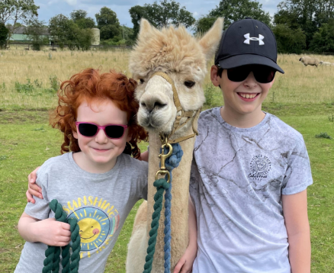

Images: montage of photos showing young people enjoying activities

Our Children, Young People and Families Service has supported 222 families over the past 12 months, providing both support to the parents of vision impaired children and a range of fun activities for the children to take part in, including canoeing, archery, pizza evenings, music sessions, theatre trips, match day tickets to watch Norwich City play at Carrow Road, and not forgetting our annual summer and Christmas parties and Christmas Train Trip.

All of these events are set-up in a way which promotes the child’s confidence and social skills in a safe, friendly and welcoming environment, whilst also giving parents an opportunity to receive support and share experiences with other parents.

**Montage of images showing things which happened during the year:**

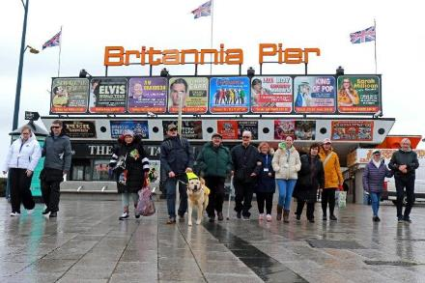

A walking group steps out on Great Yarmouth seafront as part of a programme of monthly seaside walks organised by the town’s hub team

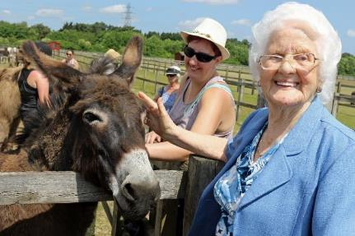

Sheila Burgess (right) and Kylie Reed say hello to a donkey during a visit to Redwings Horse Sanctuary

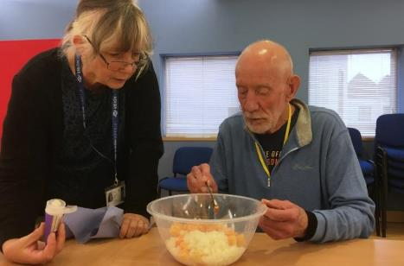

Held across the county, the hugely popular ‘Cooking With Sue’ sessions are aimed at helping vision impaired people lead independent lives

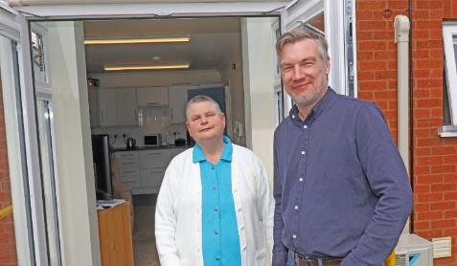

Hammond Court resident Kate Pentney shows Vision Norfolk chief executive Andrew Morter her newly-refurbished flat

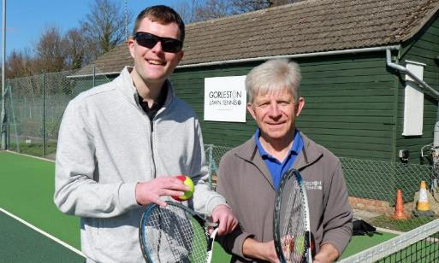

Professional tennis coach Mike Reynolds, pictured here with Vision Norfolk’s Ed Bates, led a series of vision impaired tennis lessons

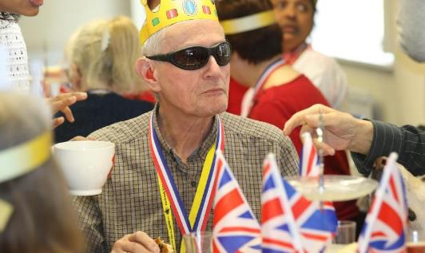

The Great Yarmouth hub threw a part to celebrate the coronation of Vision Norfolk Patron King Charles

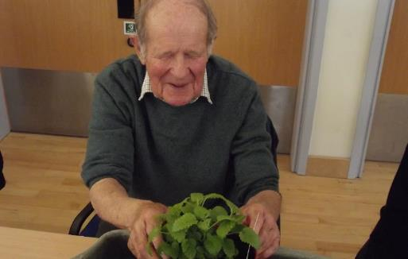

A special one day workshop at the Norwich hub aimed to show that sight loss does not need to be a barrier to enjoying gardening

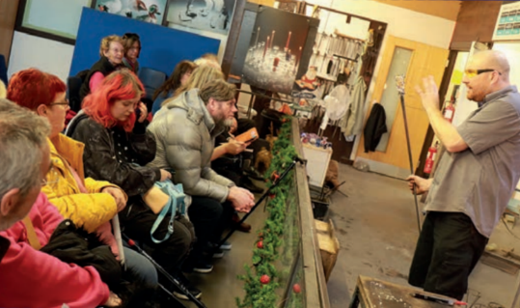

During a visit to Langham Glass at Fakenham, a group were able to try their hand at making glass baubles for the Christmas tree

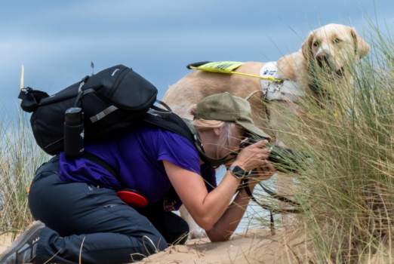

Our Effstopeyes photography group meets fortnightly across the year, enjoying a range of shoots across the county

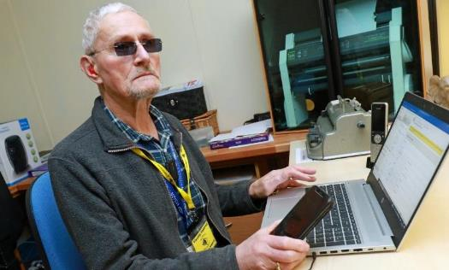

Vision impaired volunteer David Page offered one-to-one training sessions to help vision impaired people get to grips with the latest technology

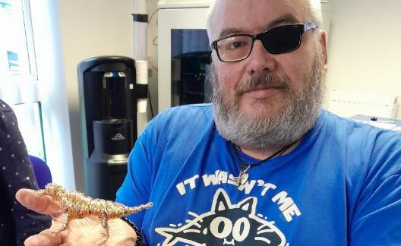

A series of art workshops at the King’s Lynn hub saw participants create a range of two- and three-dimensional artworks

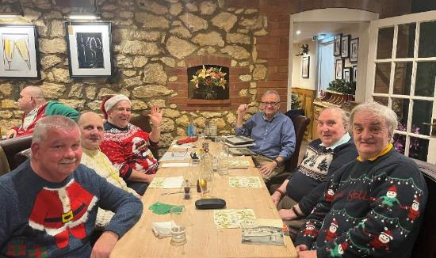

The West Norfolk Men’s Group seeks to tackle social isolation, and has resulted in many friendships

***Vision Norfolk Volunteers***

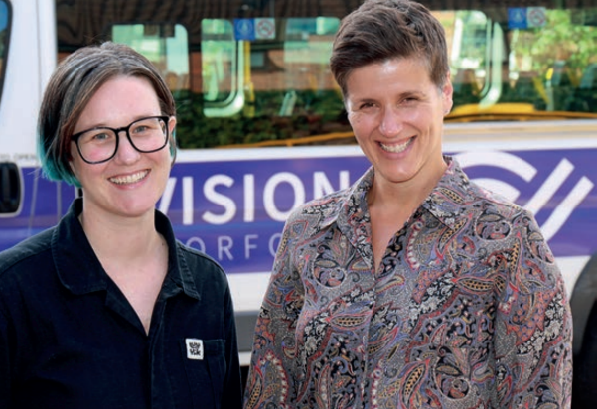

Image: Vision Norfolk volunteer engagement co-ordinators Sophie Chapman-Smith (left) and Emily Orford

The role played by Vision Norfolk’s wonderful army of volunteers in delivering services to clients and ensuring the smooth running of the charity is immense.

Over 100 volunteers are involved across the organisation, from telephone befriending to driving minibuses, fundraising to helping out on leisure activities.

“Without our wonderful volunteers we would simply not be able to offer the range of services that we do for vision impaired people across Norfolk,” says Vision Norfolk chair of trustees Karen Norton.

“The demand for our services continues to grow, and it is only through the dedication and loyalty of our army of volunteers that we are able to meet that demand.

“Volunteering is a richly rewarding thing to do, and we would very much welcome anyone who is thinking of volunteering some time to consider helping Vision Norfolk.”

The importance of our volunteers was underlined by the appointment of two experienced volunteer engagement co-ordinators, Sophie Chapman-Smith and Emily Orford (on a job-share), to help recruit and support volunteers across the charity.

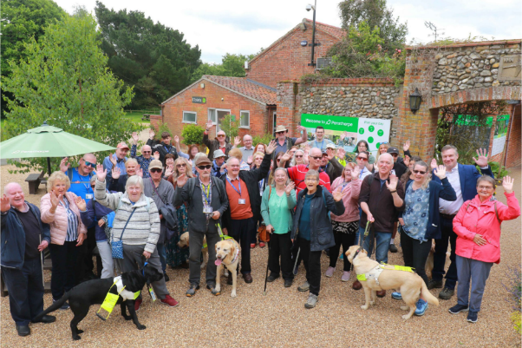

Image: Vision Norfolk celebrated the contribution of its volunteers by taking a group of them on a special trip to Pensthorpe Wildlife Park near Fakenham

**Sidebar**

Would you like to offer your services as a volunteer for Vision Norfolk?

Our team of volunteers undertake a huge range of activities, including helping at sports and leisure activities, advising at eye clinics, being Telefriends, driving, fundraising, escorting and guiding, and working in the charity’s equipment and information centres.

For more information, go to [www.visionnorfolk.org.uk/get-involved/volunteer](http://www.visionnorfolk.org.uk/get-involved/volunteer), email [volunteers@visionnorfolk.org.uk](mailto:volunteers@visionnorfolk.org.uk), or call on 01603 573000.

**Case Study: Janet Head**

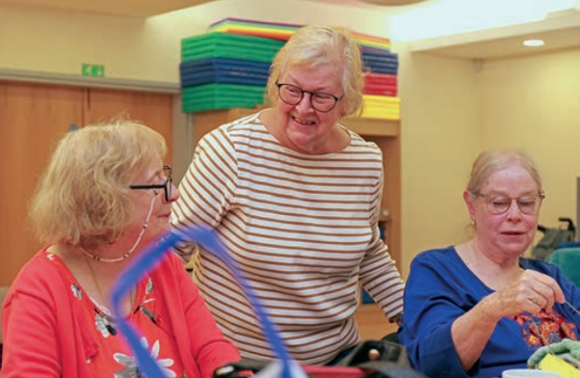

Image: Volunteer Janet Head helping at a craft session

Retired legal secretary and teacher Janet Head is one of a number of volunteers who helps keep Vision Norfolk’s busy programme of leisure activities running.

Janet runs the monthly audio book club in Norwich, as well as helping at the weekly craft sessions and supporting vision impaired people on trips, theatre visits and walks. Janet has cataracts and glaucoma, but says her sight is still “pretty good”, and she is still able to drive.

“I can’t imagine sitting around and doing nothing,” she says. “My motivation for volunteering is that I believe you can go on learning for ever if you put your mind to it, and volunteering allows you to do just that.

“I enjoy the company and friendship in getting involved, it keeps my brain ticking over, and it helps me keep active. They are such nice people at Vision Norfolk!”

Janet values the training and support she receives from the charity. “When you volunteer, the organisation helps you know what you are going to do and what you need to know, which is important. It is also nice to feel appreciated for what you do.”

***The Financial Year***



*Image: Julian Foster*

Following the exceptional surplus generated last year from the sale of Thomas Tawell House, we expected income in the current year to reduce significantly and we budgeted for a large deficit this year. This deficit did not materialise as generous legacy receipts and good investment performance left us with a small deficit of £66k, only slightly worse than last year’s deficit of £31k.

We completed our planned change of constitution to a Charitable Incorporated Organisation at the end of the year, which involved a transfer to a new charity named ‘Vision Norfolk’. This brings our governance arrangements up to date under the new constitution. In all other respects our services and financial position remain unaltered.

At a time when all charities are finding fundraising challenging, and when costs are soaring, Vision Norfolk would be facing a significant year-on-year deficits without legacy income. It underlines just how important legacy income is to the financial wellbeing of our charity.

During 2023-24 our investment income increased, following the poor stock market returns in 2022-23. We are hopeful that this trend will continue.

A declining trend in income from traditional fundraising sources (in common with the entire charitable sector) has resulted in us running a significant underlying deficit. The trustees are aiming to correct this over a period of time to put the charity on a more sustainable footing.

Both legacy and investment income are quite volatile; the economic situation in the coming years is difficult to predict, and legacies are by their very nature not something we can plan for. We have allowed for this volatility in our future financial plans.

In tough economic times we remain acutely aware of our financial position and the need to balance our costs and income as soon as we can, so as to maintain and expand services for vision impaired people in Norfolk.

*Julian Foster, Treasurer*

* Financial position for the year break even following good legacy receipts and investment performance
* Income reduced by 54% following last year’s exceptional sale of Thomas Tawell House in 2022
* Expenditure reduced by 38% to £1.41 following the sale of Thomas Tawell House
* Investment income and revaluation gains increased to a surplus of £406k from a deficit of £50k last year
* Net expenditure was £66k, after a deficit of £31k last year
* Charity funds reduced slightly from £8.9m to £8.8m

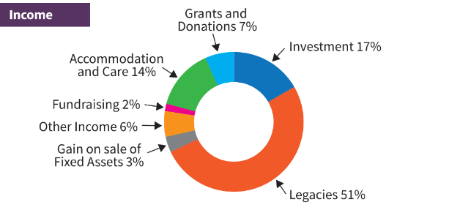

Image: Graphic illustrating the Incoming during 2023/24 with the percentages noted below.

Income:

* Legacies 51%
* Investment 17%
* Accommodation and Care 14%
* Grants and Donations 7%
* Other Income 6%
* Gain on Sale of Fixed Assets 3%
* Fundraising 2%

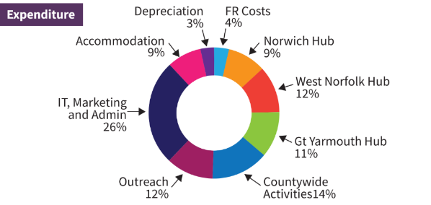

Image: Graphic illustrating the Expenditure during 2023/24 with the percentages noted below.

* IT, Marketing and Admin 26%
* Countywide Activities 14%
* Outreach 12%
* West Norfolk Hub 12%
* Gt Yarmouth Hub 11%
* Norwich Hub 9%
* Accommodation 9%
* FR Costs 4%
* Depreciation 3%

Annual Review 2023 –2024

**Norwich Hub**

Bradbury Activity Centre

Beckham Place

Edward Street

Norwich

NR3 3DZ

01603 573000

**King’s Lynn Hub**

20 Thoresby College

Queen Street

King’s Lynn

PE30 1HX

01553 660808

**Great Yarmouth Hub**

12 Hall Quay

Great Yarmouth

NR30 1HP

01493 745973

Full financial accounts, details of Patrons, Presidents, Vice-Presidents, Trustees, Executive Staff and other officers, along with other statutory information, can be obtained by downloading the charity’s 2023/24 Financial Statements from www.visionnorfolk.org.uk/about-us/reports.

Printed copies can be requested by calling 01603 573000.

To receive this report in other formats (Braille, larger print, audio CD & USB and email) please contact: office@visionnorfolk.org.uk or 01603 573000.

Vision Norfolk is a charity registered in England and Wales (no. 1206599).