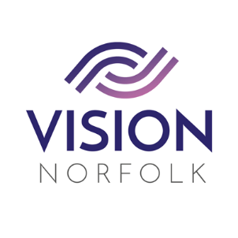

Role Title: | Volunteer Support for Cooking Sessions
Hours and Location: | Vision Norfolk, Bradbury Activity Centre, Beckham Place, Norwich, NR3 3DZ. Thursdays 2.00pm – 4.00pm  2024 dates: 24th October, 21st November, 19th December
About the organisation: | We are Vision Norfolk and our mission is to support people living with sight loss to enjoy active, independent and fulfilled lives.
About the role: | To provide support for Vision Norfolk clients during our monthly cookery classes.
Main Responsibilities | To help support our clients at the monthly practical cooking classes. These sessions aim to teach practical skills which are transferrable to the home kitchen. Each session focuses on a different dish.
General Responsibilities: | - Telephone the COW as soon as possible if unable to fulfil your commitment so that replacement cover can be arranged.  - Maintain strict confidentiality at all times.  - Adhere to the Vision Norfolk volunteer policies and procedures including Health & Safety.  - Volunteers must wear their photo identity badge during all assignments.  - We ask our volunteers to remain kind and courteous when you are representing Vision Norfolk.
Benefits of Volunteering in this role: | Becoming a volunteer is a wonderful opportunity to make a difference and support your local community. Vision Norfolk also offers:  - Regular advice, support, and training  - Payment of out of pocket expenses agreed in advance
Contact details: | To discuss this role or other opportunities please contact the Volunteer Engagement Coordinators on 01603 573000 or volunteers@visionnorfolk.org.uk. We also have application forms available on our website: www.visionnorfolk.org.uk

