**Vision Norfolk Magpie News**

**Spring 2025**

Welcome to the Spring edition of Magpie News with updates from Vision Norfolk, your local sight loss charity.

If you would like this newsletter in another format please let us know by calling 01603 573000 or emailing office@visionnorfolk.org.uk. Magpie News is currently available by mail in printed, Braille or audio format on a memory stick or CD. A digital format is also available on our website and by email as a Word document or a PDF.

**Celebrating 220 Year of Vision Norfolk**

At Vision Norfolk, we are excited to mark our 220th year of supporting individuals with vision impairment in Norfolk, helping them live independent and fulfilling lives. To celebrate this incredible milestone, we’re launching our 220 Fundraising Challenge to help sustain the vital services and activities we provide.

We’re inviting everyone to take part by creating their own fun and creative challenges inspired by the number 220. Whether it’s a sponsored walk of 220 steps a day, doing 220 star jumps, or setting a goal to raise £220, the possibilities are endless! Perhaps you could organise a bake sale, host a coffee morning, or sell something you’ve made. The best part is, you get to choose the challenge!

No matter how much you raise—big or small—it will make a real difference to someone with a vision impairment in Norfolk.

So, spread the word to your friends and family! We’d love to have as many people involved as possible.

For more information, head over to our fundraising page on the website. There, you’ll find helpful tips, and everything you need to get started. https://www.visionnorfolk.org.uk/get-involved/fundraising/

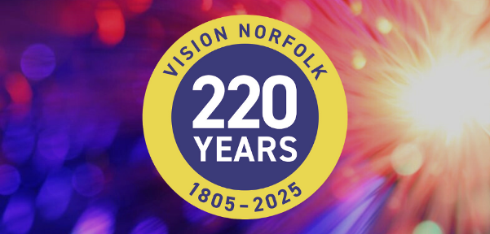

Image: A circular blue, yellow and white badge with the text “Vision Norfolk, 220 years, 1805-2025”. The background is an explosion of colours.

**In This Edition**

Vision Norfolk News – Page 1

Updates from your local sight loss charity

Children, Young People and Families – Page 8

Learn about our services for local people aged 0 to 25 and their families

Equipment and Technology – Page 10

Updates about equipment and technology including upcoming events and opportunities

Norwich and South Norfolk – Page 11

Updates from our Norwich Community Hub and upcoming events and activities in Norwich and South Norfolk

West Norfolk – Page 19

Updates from our King’s Lynn Community Hub and upcoming events and activities in West Norfolk

East Norfolk – Page 27

Updates from our Great Yarmouth Community Hub and upcoming events and activities East Norfolk

Useful Information – Page 33

Learn about blue badges and accessible parking

Contact Details – Page 36

Find out how to reach us with your questions

**Happy official start to the spring season and welcome to our first newsletter of 2025!**

We are continuing to provide individualised support to anyone experiencing sight loss in the Norfolk area, as well as friends, family and other supporters. We can provide assistance answering questions, understanding benefits, exploring assistive technology, providing important emotional support and building community across the county. Please reach out if you have any concerns and we can talk through possible solutions.

With longer, drier days ahead we are restarting many of our outdoor social and wellbeing activities including guided walks, tennis session and days out to experience some of the amazing places around Norfolk. You can find a full list of upcoming activities later in this newsletter or get in contact with your local community hub to find out more.

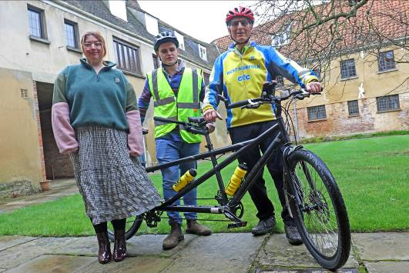

Image: A rider, a piolet (cycling guide) and a member of staff standing next to a tandem bicycle inside the courtyard of Thoresby College.

**Have Your Voice Heard**

Are you interested in becoming part of Vision Norfolk’s User Group? This group of clients meets monthly to assist Vision Norfolk staff in ensuring we are delivering the best services for everyone in the county living with sight loss. While the group cannot make executive decisions for the charity, the service users are able to feedback recommendations to staff who look to see what can be taken on board.

The group meets alternately online and in Vision Norfolk’s three community hubs. If you are interested in finding out more, please email usersgroup@visionnorfolk.org.uk or call Edward on 01493 745973.

**Fundraisers for Vision Norfolk**

We have some fantastic supporters who are completing challenges this year in order to support Vision Norfolk’s work.

Steph Evans will be running the London Marathon in April. Steph was born with a cataract on her left eye and as the eye had never developed any vision, when this was removed there wasn't anything that could be done to gain the sight. After being given a place at the London Marathon she thought it was only right to raise some money for a local charity supporting individuals with sight loss. This marathon is going to be particularly hard as she is running it just three weeks after running the Milan marathon! You can find out more and support Steph through her JustGiving page ‘Steph's fundraiser for Vision Norfolk’.

Gemma Oldman is also running the London Marathon this year. She was inspired to raise money for Vision Norfolk after seeing the support that the Children, Young People and Families Department has been providing to a close friend. You can find out more and support Steph through her GoFundMe page ‘Gemma’s London Marathon 2025 fundraiser for Vision Norfolk’.

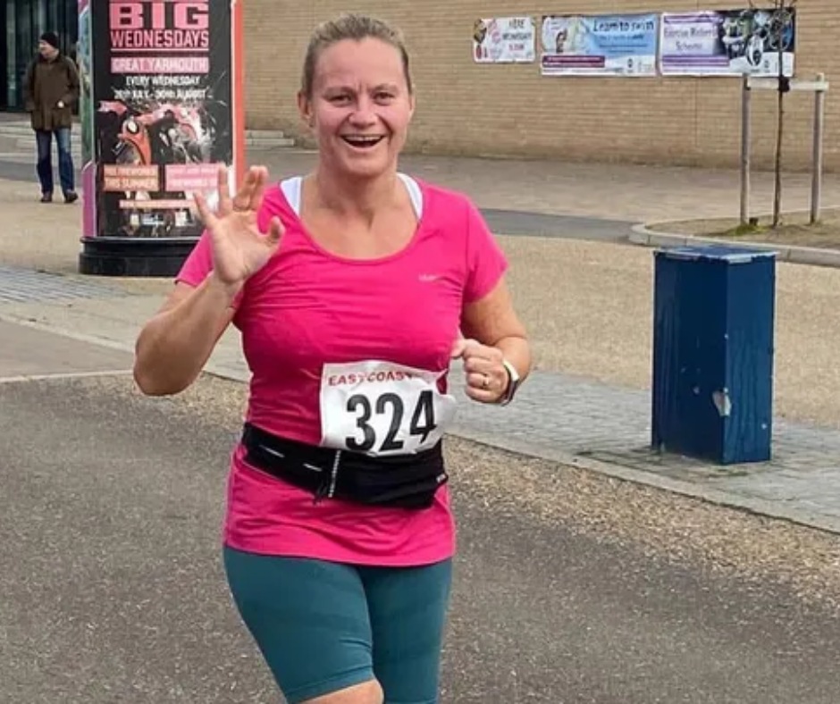

Image: Gemma Oldman waving at the camera as she runs past wearing a pink top and a runner’s bib.

Clare McCarthy, who swam Lake Conniston last year in aid of Vision Norfolk and Guide Dogs UK, is back swimming the Chill Swim Triple Crown. She will be swimming Lake Conniston (5.25 miles) in June, Ullswater (7.5 miles) in July and Windermere (11 miles) in September. Clare was born with albinism and is severely sight-impaired. You can find out more and support Clare through her JustGiving page ‘Clare's fundraiser for Vision Norfolk’.

We are extremely grateful to all our supports past, present and future!

If you have any fundraising queries please contact us at fundraising@visionnorfolk.org.uk.

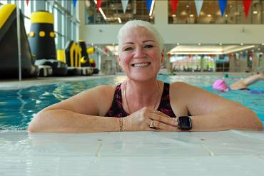

Image: Profile picture of Clare McCarthy smiling at the camera while standing in the pool at The Reef Leisure Centre. Behind her someone is swimming.

**Taverham Lions Club Donation**

Vision Norfolk has been given a boost after Taverham Lions Club chose the county’s sight loss charity to be one of the beneficiaries of its fundraising activities during 2024.

The Lions donated £500 raised from a range of fundraising activities during the year, including running a car park in Thorpe for Norwich City supporters attending home games, a series of summer barbecues, and the traditional Christmas Santa float.

Taverham Lions president Sue Howes presented a cheque to Erin Snell, Community Fundraising Officer at Vision Norfolk, during a visit to the charity’s Norwich hub where members of the Lions found out more about the charity’s work.

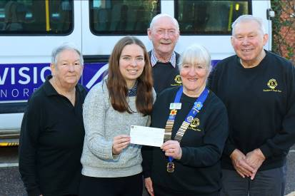

Image: Four members of the Taverham Lion’s Club, in black and yellow branded tops, handing over the cheque to Vision Norfolk’s Community Fundraising Officer.

**Children, Young People and Families**

The Children, Young People and Families department has been incredibly active over the busy Christmas period and the start of the New Year, organising a range of exciting and engaging activities designed to bring joy and create memorable experiences for children and their families. Among the highlights was a delightful visit to the Norwich Theatre Royal Pantomime, a magical journey aboard the Christmas Train, and our annual Christmas Party, which was packed with games, music, and a special visit from Santa. These events were the perfect way to end the year on a high note and spread festive cheer.

During the February Half Term, we ensured there was something for everyone, catering to different age groups with a variety of fun-filled activities. For our teenagers, we arranged a thrilling trip to an escape room, while families could enjoy a games afternoon, a visit to the Dinosaur Park, and an inclusive tennis session. As we approach the warmer months, we’re looking forward to even more exciting events, including a dance workshop, a karate session, a trip to a guinea pig café, and an adventure at Bewilderwood.

We continue to offer our much-appreciated one-on-one emotional and practical support for families, providing a vital service that helps them navigate the challenges of vision impairment. This includes home visits, guidance on available benefits, grants, and funding for children with sight loss, as well as referrals to a wide range of relevant services and organisations. Additionally, our new online parent forums have been a huge success, creating a valuable space for both new and existing families to connect with each other and with professional guests. These forums will continue on a monthly basis, giving parents the opportunity to ask questions, share experiences, and gain helpful advice.

We always welcome your input and ideas, so if you have suggestions for new activities or ways we can enhance our support, please don’t hesitate to reach out. You can contact us at CYPF@visionnorfolk.org.uk with any questions or ideas for 2025.

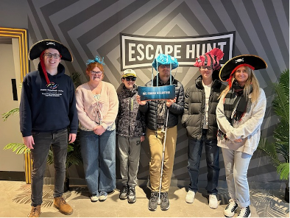

Image: Two staff members and four teens standing by the Escape Hunt sign. They are wearing ocean themed hats and holding a sign that says “We found Atlantis”.

**Equipment and Technology**

**Opportunities to Talk About Technology**

Tea and Tech – Norwich, Last Monday of the Month, 1:30pm-3:30pm

Rachael and Darryl Andrews invite you to come along to the Norwich Hub to chat about your technology products. This is not a training session but a discussion session for likeminded people to talk about technology. Please contact Richard on 01603 573000 extension 322.

Technology Support Sessions – Great Yarmouth, Last Wednesday of the Month, 1pm-2pm

One of our volunteers is offering oneto-one help and support to anyone who might be experiencing issues with their technology. Please be aware these free sessions will need to be booked in advance. Please contact Catherine on 01493 745973.

**Tech Tip – Introducing Be My AI**

The free app Be My Eyes has recently added an additional feature called Be My AI which provides an image and text description option for people with vision impairment. The Be My Eyes App connects blind and partially sight people to sighted volunteers across the globe through a live video connection. You can use your camera-enabled smartphone to request instant video support with basic tasks such as sorting laundry, reading labels and describing artwork.

The Be My AI feature has been recently been introduced to provide similar support through a discussion with an AI assistant. You can ask the AI to describe a picture in-depth and then have a conversation where you ask follow up questions or send additional pictures to gather more information.

When you open the Be My Eyes App you are presented with the ‘Get Support’ tab which allows you to call a volunteer. However you can choose to navigate to the Be My AI tab on the bottom of the screen instead. This allows you to take a picture which the app will analyse and describe in depth including any text. You can then either take another picture or press ‘Ask More’ to start a conversation. If you choose to start a conversation a chat will open where you can ask follow up questions, such as asking to describe a specific part of the picture, a persons’ expression, or the colour of different pieces of clothing.

The artificial intelligence is not perfect so the app suggests that you call a volunteer for any safety instructions, such as reading medicine labels. You can choose to call a volunteer at any time by pressing a button in the AI chat or by closing the chat and returning to the regular “Get Support” tab.

The text reading of the app may not be as accurate as other apps like Seeing AI. However Be My AI does allow you to ask questions about text instead of reading the text from beginning to end, for example summarising a letter or asking about a specific dish on a menu.

The Be My AI feature should now be available on any devices that has the most up to date version of the Be My Eyes App.

**Norwich Hub Updates**

**Touching Turner Workshop**

On Tuesday 11th February, a group of 20 vision impaired people from the Vision Norfolk Heritage Group attended two sessions in the Colman Gallery of Norwich Castle and Art Museum to explore the Walton Bridges painting by JW Turner.

Curators Dr.Maja Jackson and colleague Jan Pitman, held a session with raised tactile images of the paintings and lots of verbal descriptions which explained what was in the painting.

In order to make the session more inclusive several handling objects were also available on a handling table, including a very heavy head collar for a horse, including the head rains and blinkers, actual horse shoes, cloth to represent the sails on the boat in the painting. Dried herbs were also available in a bowl for the group to smell to represent what was at the front of the painting, growing along the water’s edge of the Thames River.

During the sessions both Jan and Maja gave their impressions of what the painting looked like and this helps to bring the session alive to the group members.

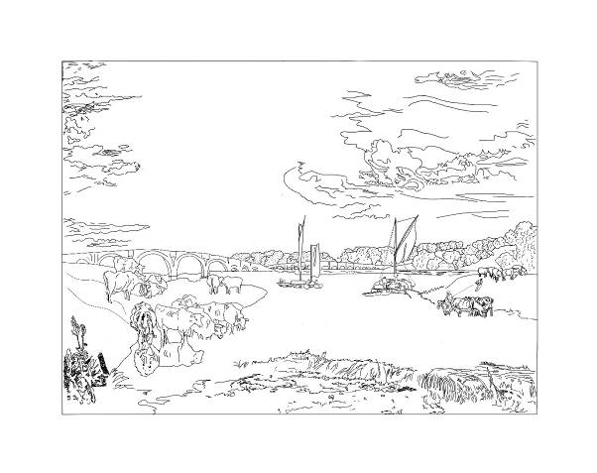

Image: An outline of the Walton Bridges painting by JW Turner, which was used to make a tactile representation of the piece. There is a bridge across a river with sail boats in the background and grazing cows in the foreground.

**Getting Out in the Garden**

Our Allotment Project is taking shape now that the raised bed has been made and is awaiting a large delivery of soil. We are hoping to have a group visit before the end of March. Lots of ideas have been put forward as to what you would like to grow. If you are interested in helping or volunteering, please contact Mark or Helen. The plot is at Marlpit Community Garden. This project is funded by Norfolk Community Foundation through the Greening Our Communities Fund.

**Evening Activities**

We are looking at holding some of our social and wellbeing activities in the evening to make them available for everyone to take part, especially those who work during the day. At the moment we are organising events once or twice a month on Tuesday. This has begun with our extremely popular evening bat walk at Blickling Hall which took place on 25th March.

If you are interested in taking part in evening activities can you please call Richard on 01603 573000 extension 322 to let him know what kinds of activities will best support you.

**Escape Rooms**

Escape rooms are three dimensional puzzles, were teams are “trapped” in a room, or a series of room and must interact with the room and solve a series of riddles in order to win by escaping.

Some of the teens in the Children, Young People and Families service have been taking part in escape rooms and have found them extremely rewarding. Our Norwich activities team is considering setting up an accessible escape room visit for our adult service to take part in.

Is this something that you might be interested in? Please call Richard on 01603 57300 extension 322 for more information.

**What’s On – Norwich and South Norfolk**

Unless otherwise stated please contact Richard on 01603 573000 extension 322 or richard.polley@visionnorfolk.org.uk.

Please note: Some of our activities are very popular. Please get in contact if you are interested and if the activity is already full we can put you on the waiting list for when spaces become available.

**Special Events**

Creative Writing Open Afternoon – Norwich, 20th May, 2pm-4pm

If you’re at all interested in Creative Writing and would like to find out more about what our group gets up to, then please pop along to our Open Afternoon. There will be some short readings and an opportunity for people to come along and find out more about the group with volunteers Emma and Maggie. Contact Mark on 01603 573000 extension 341.

Chicago – Norwich, 19th July, 2:30pm-5pm

Join Vision Norfolk for an accessible outing to Norwich Theatre Royal to see Chicago. Set amidst the razzle-dazzle decadence of the 1920s, Chicago is the story of Roxie Hart, a housewife and nightclub dancer who murders her onthe-side lover after he threatens to walk out on her. Tickets cost £59 including a sighted guided if required and must be booked by the 19th May. Contact Mark on 01603 573000 extension 341.

**Regular Activities**

Allotment Project

Are you interested in gardening, or just want to spend some time out in the fresh air? Vision Norfolk has a plot at Marlpit Community Garden that we are using to explore accessible gardening practice out in the real world. This project is funded by Norfolk Community Foundation through the Greening Our Communities Fund. Contact Mark on 01603 573000 extension 341.

Arts and Crafts – Norwich, Every Thursday, 10am-12:30pm

Undertake a variety of arts and crafts with support from Helen and the volunteers. Contact Helen on 01603 573000 extension 342.

Audiobook Clubs

Our friendly, informal audiobook clubs offer a chance to get together and enjoy a chat about a chosen book. The book clubs are free to join and the audiobooks are supplied. Contact Mark on 01603 573000 extension 341.

Diss Audiobook Club – 4th Friday of the Month, 2pm-3:30pm

Norwich Audiobook Club – 2nd Monday of the Month, 1:30pm-3pm

Boccia – Norwich, 1st and 3rd Friday of the Month, 10am-12pm

Join us for the competitive precision ball sport boccia. Sessions are open to all abilities and levels of experience.

Bowling – Norwich, 2nd and 4th Friday of the Month, 9:30am-1pm

Come and enjoy some friendly competition with ten pin bowling at Namco Funscape. Transportation available from the Norwich Hub. Regular bowling fee to be paid to Namco Funscape.

Bowls – Norwich, Every Tuesday, 10am-12pm

Come and enjoy some friendly competition with the traditional British game short mat bowls.

Braille Classes – Norwich, Every Thursday, By Appointment

Join our Braille class taught by one of our volunteers. The classes are small, usually on a one-to-one or one-to-two basis.

Coffee Mornings and Socials

Come and enjoy a cup of coffee and a chat at one of our socials.

Attleborough Drop-in Cafe – Fortnightly, 11am-12:30pm, contact Chris Linstead on 07743 921430

Norwich Coffee Morning – Last Monday of the Month, 10am-11:30am

Norwich Drop-in Café at Plumstead Road Library – Fortnightly on a Wednesday, 11am-12pm, contact Jo on 01603 573000 extension 454.

Thetford Drop-in Café – 4th Wednesday of the Month, 2pm-3:30pm, contact Chris Linstead on 07743 921430

Cooking with Sue – Norwich, Monthly on a Thursday (27th March, 24th April, 22nd May, 19th June), 2pm-4pm

Each month we will be running a free cookery lesson at our Norwich Hub teaching practical skills that can be used at home.

Creative Writing – Norwich, 3rd Tuesday of the Month, 2pm-3:45pm

Join a creative writing group that will give you the opportunity to express yourself through the written word. Contact Mark on 01603 573000 extension 341 for more information or come along to our open day in May.

Darts – Norwich, 1st and 3rd Friday of the Month, 1pm-3pm

Join us for a few friendly games of darts. Volunteers are around to help you position or read the numbers on the board if needed.

Glaucoma Support Group - Norwich, 2nd Friday of the Month, 2pm-3:30pm

A self-help and discussion session for local people living with Glaucoma created in partnership with Glaucoma UK. We sometimes have speakers in to talk about Glaucoma and other subjects.

Macular Group – Norwich, 2nd Friday of the Month, 12pm-1:30pm

This group is organised and run by the Macular Society. Vision Norfolk staff usually give an update on new equipment and activities and there are sometimes guest speakers.

Photography Group – Norwich, 1st and 3rd Friday of the Month, 1:30pm-3:30pm

The first meeting in each month is an outdoor photoshoot and the second is an indoor opportunity to review photographs. Some outing may have a cost for refreshments. Contact Helen on 01603 573000 extension 342.

Sailing – Norwich, Motor Cruiser on the 3rd Thursday of the Month, Sailing fortnightly from 8th May, 12:30pm-5pm

Come and enjoy an afternoon on the Norfolk Broads. We will be going out on the covered motor cruiser through April and then will be returning to fortnightly sailing sessions in May. There is a suggested donation of £20 per session paid directly to the Nancy Oldfield Trust. Contact Mark on 01603 573000 extension 341.

Tennis – Norwich, 4th April and then fortnightly from Friday 25th April, 11am-12pm

Our inclusive fortnightly tennis session are returning to Waterloo Park with a coach from the National Tennis Association.

Yoga – Norwich, Every Tuesday, 1pm2pm and 2:15pm-3:15pm

Come stretch and relax with yoga. Sessions are designed to be accessible to all abilities and levels of experience.

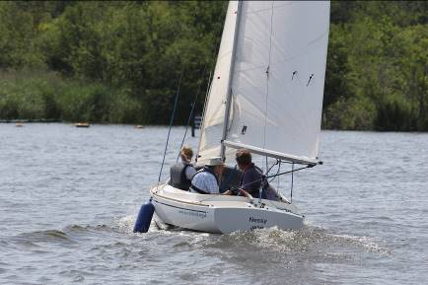

Image: Three people in a small sail boat on the Norfolk Broads. The boat has the name “Nessy” on the back and the website “www.nacyoldfield.org. uk” on the side.

**King’s Lynn Hub Updates**

**New Indoor Bowls in Fakenham**

People living with sight loss are being invited to take part in a free monthly indoor bowls session in Fakenham – where players are demonstrating that vision impairment is no barrier to taking part.

The sessions take place on the first Friday of every month at Gallow Indoor Bowls Club in the town.

They are run by volunteers Roger and Rosamund Johnson, who say that those taking part enjoy the social aspect alongside the opportunity to take part in the sport.

The level of sight loss varies among participants, from those with blurred vision as a result of glaucoma, through to players who have no vision at all.

Included in those is 74 year-old Mike Davies from Hindringham, who has been completely blind since he was 27. He is guided by Roger Johnson, who stands a little way up the green and provides audible cues as to where Mike needs to bowl.

“I absolutely love it,” says Mike, who took up the sport a year ago. “The way the session is run means I can take part in a sport which I never thought I could do. And the social side is really important as well; it’s a really friendly group and I look forward to getting out and having a natter with them every month as well as getting on the green.”

That view is backed up by regular participant Bob Maple from Fakenham, who has no central vision and limited peripheral vision as a result of age-related macular degeneration (AMD). Bob had a career in the RAF specialising in electronics before running his own garage business in the town.

“There is no doubt that it’s a challenge to play bowls when you can’t see properly, but I have found that I really enjoy it, and I can actually play quite a good game now. It just goes to show that you can do anything if you try; if you don’t try, you will never know.”

To find out more contact Abbi Waters on 01553 660808, or visit www. visionnorfolk.org.uk/bowls.

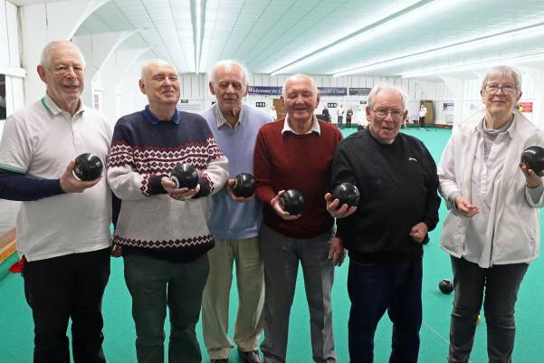

Image: Six members of the Fakenham Bowls club standing inside Gallow Indoor Bowls Club, showing off their bowl balls to the camera.

**King’s Lynn Drop-In Café**

Please note that the King’s Lynn Drop-in Café has returned to our previous venue of The Globe on Tuesday Market Place. Please drop by on the third Wednesday of the month from 10am to 12pm to chat to one of our staff members about any questions or concerns you have.

We also have a King’s Lynn Coffee morning twice a month at the Vision Norfolk Hub where you can come, sip some hot drinks and socialise with other local people living with sight loss.

**Plans for 2025**

We have been working on putting together an exciting calendar of events for 2025 to give everyone the chance to get out, meet new people and explore what Norfolk has to offer. In the next few months we will be taking special trips out to Ken Hill, the beautiful Stody Lodge gardens and we are in the process of organising a seaside adventure in Hunstanton complete with a trip on one of the famous amphibious vessels, the Wash Monsters.

Our events and activities are designed to support the social wellbeing of local people with sight loss by allowing accessible opportunities for local people to meet up, socialise and learn new skills. If you have any questions or suggestions of how we can better support you please let us know!

**What’s On – West Norfolk**

Unless otherwise stated contact Abbi on 01553 660808 or kingslynnhub@visionnorfolk.org.uk.

**Special Events**

Fred’s Quiz – King’s Lynn, 28th April, 1pm-3:30pm

Bring your best trivia knowledge for a chance to win the Hargreaves cup.

Ken Hill Walk – King’s Lynn, 1st May, 10:30am-1pm

Wild Ken Hill combines rewilding, conservation, and sustainable farming in a unique 4,000 acre setting on the West Norfolk coast. Join Vision Norfolk for a guided tour.

Stody Lodge Gardens – Melton Constable (Transportation from King’s Lynn), 8th May, from 1pm

Join us for a walk through the floral sights and smells of Stody Lodge Gardens. Please bring a packed lunch.

Seaside and Wash Monster – Hunstanton (Transportation from King’s Lynn), June

Join us on a trip to the Hunstanton seaside to enjoy the fresh air and learn about local wildlife with a tour on one of the famous amphibious vessels, the Wash Monsters. The exact date is still being confirmed, so please get in contact for more information.

**Regular Activities**

Archery

Join one of our free archery sessions designed to be accessible for all abilities and skill levels.

Downham Market Archery - 1st Monday of the Month, 4pm-6pm

Fakenham Archery – 4th Wednesday of the Month, 2pm-4pm

Art Workshops – King’s Lynn, 1st Friday of the Month, 1pm-3pm

We hold regular small art workshops with painting, print making, collage and more. Free to attend and no prior experience necessary.

Audiobook Clubs

Our friendly, informal audiobook clubs offer a chance to get together and enjoy a chat about a chosen book. The book clubs are free to join and the audiobooks are provided. Contact Mark on 01603 573000 extension 341.

Dereham Audiobook Club – 3rd Wednesday of the Month, 10:30am-12pm

Fakenham Audiobook Club - 3rd Monday of the Month, 10:30am-12pm

Gaywood Audiobook Club – 1st Thursday of the Month, 2pm-3:30pm

Bowling

Join other local people with sight loss for a good chat and a lively game or two with assistance available if required.

Dereham Bowling - Last Friday of the Month, Starting at 11am, Please contact Chris L on 07743 921430.

Gaywood Bowling – 25th April and then 4th Friday of Month, 1pm-3pm

Bowls – Fakenham, 1st Friday of the Month, 2pm-4pm

Come and enjoy some friendly competition with the traditional British game bowls. There are volunteers available at sessions to aid as necessary.

Coffee Mornings and Socials

Come and enjoy a cup of coffee, a slice of cake and a chat about everything and anything at one of our socials

Downham Market Social – 4th Wednesday of the Month, 11am-1pm

Fakenham Coffee Morning – 3rd Thursday of the Month, 10am-12pm

Fakenham Drop-in Café – 1st Thursday of the Month, 9:30am-11:30am

Hunstanton Drop-in Café – 2nd Wednesday of the Month, 10am-12pm

King’s Lynn Coffee Morning – 1st and 3rd Tuesday of the Month, 10am-12pm

King’s Lynn Drop-in Café – 3rd Wednesday of the Month, 10am-12pm.

Swaffam Drop-in Café – 3rd Thursday of the Month, 10am-12pm

Darts and Shuffleboard – King’s Lynn, 4th Thursday of the Month, 10am-12pm

Come and enjoy your choice of darts or shuffleboard with assistance and competition available as needed.

Guided Walks – King’s Lynn, Monthly on a Tuesday (15th April, 13th May, 10th June)

We are teaming up with King’s Lynn Town Guides to arrange a historic guided walks around King’s Lynn. Whenever possible we have incorporated tactile opportunities to interact with the town’s history and there will be a variety of short and long walks so that everyone can take part.

Knitting – King’s Lynn, 2nd Tuesday of the Month, 1:30pm-3:30pm

Whether you are a complete beginner who would like to take up knitting or a seasoned knitter, our sessions are a fun and sociable way of getting together with fellow yarn fans.

Pub Club – Varies Locations, 2nd Monday of the Month, 12pm-2pm

A relaxed and friendly group that meet for a chat over lunch at local pubs. The group is free to attend but some special activities and outings are paid for by participants directly.

Sit Fit – Downham Market, 3rd Friday of the Month, 1:30pm-3:30pm

A seated exercise class suitable for all adults regardless of age, gender or ability.

Sing 4 Fun – King’s Lynn, Fortnightly on Wednesday, 1pm-3pm

Join Sing 4 Fun, The Sound and Vision Choir, to improve your mental wellbeing, meet new people and most importantly have fun. The choir is run in partnership with The Workshop in King’s Lynn.

Tandem Cycling – King’s Lynn and the Local Area

Our popular tandem cycling sessions will be returning in the spring. Join guide riders from the Cycling UK West Norfolk Group for cycle trips around the local are. We are hoping to start running trips around the end of April, weather dependent. The success of our tandem cycling sessions has been greatly aided by the Borough Council of King’s Lynn & West Norfolk Small Grants Scheme whose funding has helped us purchase a new bicycle and safety equipment.

Image: The Wash Monster aquatic vehicle floating in the water. The vehicle has available at sessions to aid as necessary. Pointed teeth are painted on the front and four wheels.

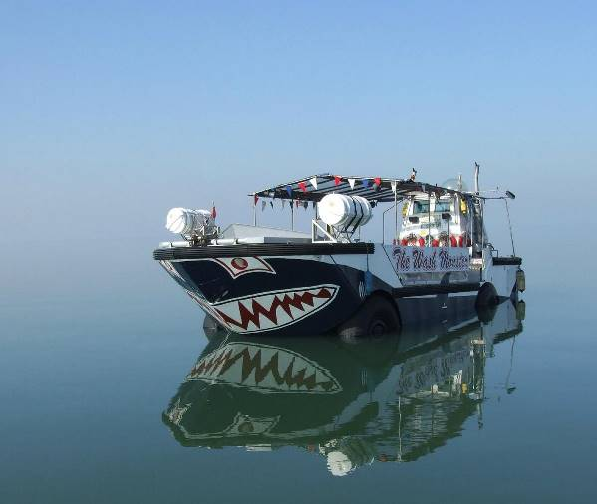

**Great Yarmouth Hub Updates**

We’ve had a busy start to the year in Great Yarmouth. Our regular activities are going from strength to strength, and we will continue these whilst looking forward to some new ones. Please read on for more information.

**News from the Winter Season**

We had a very successful trip to the Hippodrome Circus to see the Christmas Spectacular. We would like to thank everyone involved at the Circus for making the experience such a positive one for all of us.

We enjoyed our annual visit to the Pantomime where we saw Snow White. We’d like to thank St George’s theatre for allowing us in to have a touch tour a few days before the performance.

Meanwhile in the hub, our Christmas party went well as did all our pre-Christmas activities.

**New Activities to Get Involved With**

We continue to welcome people to our activities. You do need to have some form of sight loss, but all are welcome and you can bring along a companion if you wish for support.

Our creative writing group is going from strength to strength. No experience is necessary. You don’t need to be J.K Rowling or Bill Bryson. If you have something you would like to share through the written word, you are more than welcome. We accept all formats, so don’t let that get in the way.

We have two new coffee mornings out in the community that are going well. A group meets at the Rabbit Hutch in Caister on the first and third Tuesday of the month between 10am and 12pm.

Martham coffee morning takes place on the third Monday of the month at Martham Village Hall between 10 and 12. For more information about these, please contact the GY team.

We are looking to restart some previously enjoyed and successful activities, plus some new and exciting ones. Please stay tuned for more details.

**Library News**

Due to the Great Yarmouth Library moving to the old Palmers building, we have some important information about the move. The old library will close on March 14th. Therefore, our March audio book club meeting will take place in the Yarmouth Hub. The dates and times for the book club are still the same. If the building work goes to plan we will then be in the new library building from April. Please contact us if you have any questions.

**Remembering Tim Poole**

We’d like to pay tribute to one of our longer standing member, Tim Poole who sadly passed away in the middle of January. He will be greatly missed.

**New Seated Yoga Session!**

Stretch both your body and mind at our new fortnightly seated yoga sessions.

Leading the yoga is Georgina Huggins of Soulful Yoga, who says that her passion is helping people reclaim their wellbeing and feel good in both body and mind through the power of rest and mindful movement’. She has teaching qualifications with the Yoga Alliance Professionals and the British Wheel of Yoga.

Yoga is an excellent way to help people living with sight loss to become healthier physically and also improve their emotional wellbeing, but some vision impaired people are put off attending mainstream yoga classes because they feel they will be left behind.

Georgina has designed these classes specifically for vision impaired people, and she is both an excellent communicator and has a good understanding of the particular challenges of sight loss, and we are delighted to welcome her here for these special sessions.

**What’s On – East Norfolk**

Unless otherwise stated please contact Catherine on 01493 745973 or greatyarmouthhub@visionnorfolk.org.uk.

Audiobook Clubs

Our friendly, informal audiobook clubs offer a chance to get together and enjoy a chat about a chosen book. The book clubs are free to join and the audiobooks are supplied. Contact Mark on 01603 573000 Extension 341.

Cromer Audiobook Club – 3rd Monday of the Month, 2pm-3:30pm

Great Yarmouth Audiobook Club – Last Friday of the Month, 1:30pm-3pm

Bowling – Great Yarmouth, 13th May, 12pm-3pm

We run group bowling trips to Wellington Pier.

Coffee Mornings and Socials

Come and enjoy a cup of coffee, a slice of cake and a chat about everything and anything at one of our socials.

Caister Coffee Morning – 1st and 3rd Tuesday of the Month, 10am-12pm, contact Matthew on 01603 573000 extension 455

Cromer Coffee Morning – Last Wednesday of the Month, 10am-1pm, Contact Karl on 07864 615929

Great Yarmouth Coffee Morning – Every Wednesday, 10am-12pm

Martham Coffee Morning (and Snooker) – 3rd Monday of the Month, 10am12pm, Contact Matthew at 01603 573000 extension 455

North Walsham Coffee Morning – 3rd Tuesday of the Month, 10am-12pm, Contact Karl B on 07864 615929

Creative Writing – Great Yarmouth, 2nd Friday of the Month, 1pm-3pm

Our creative writing group is growing nicely, but new members are always welcome. We hope to cover a variety of different subjects, and all formats are accepted. No experience is necessary.

Fishy Friday – Great Yarmouth, 1st Friday of the Month, 1pm-2pm

Meet other local people living with sight loss and have a chat over fish and chips. Costs £6.50 per person to cover the food.

Games Morning – Great Yarmouth, Every Thursday, 10am-12pm

Join our fun and welcoming games mornings to try out cards, bingo, dominoes, and floor and table games.

Knit, Stitch and Natter – Great Yarmouth, 2nd Thursday of the Month, 1pm-2pm

Join Norfolk Knitters at our group where we learn together how to knit and stitch along with having a good natter.

Rug Workshops – Great Yarmouth, Last Friday of the Month, 10am-12pm

Join experts from local business Ruskin’s Rugs at the hub. Use their rug making kits to make your own rugs and wall hangings.

Tennis Sessions – Gorleston, Last Tuesday of the Month from April

Give tennis a try at special sessions led by LTA-accredited coach Mike Reynolds.

Weaving Group – Great Yarmouth, Every Friday, 10am-12pm

Use different types of soaked cane to make baskets of all shapes and sizes. The last Friday of each month weaving will be replaced with rug workshops.

Yoga – Great Yarmouth, 1st and 3rd Wednesday of the Month, 12pm-1:30pm

We recently started a new yoga session with Georgina Huggins, a yoga therapist and teacher. Open to all abilities, no experience is required.

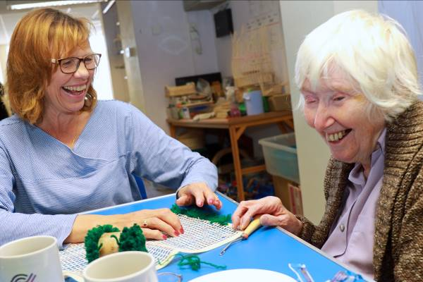

Image: Two woman sitting at a table laughing. In front of them is yarn and a mat with holes to make a small decorative rug.

**Other Information**

**Blue Badges**

A blue badge allows vehicles to legally park in accessible parking spaces closer to the destination. They allow qualifying people with disabilities to more easily access shops, entertainment, leisure and more. In certain instances, such as when parking at an “on-street” parking meter or pay-and-display, displaying a blue badge means that you do not have to pay or it removes time limits on parking. These rules can vary from car park to car park so do make sure to check ahead of time if you are relying on a blue badge to park.

You do not have to drive to use a blue badge. A driver can use their passenger’s blue badge when supporting a vision impaired person, or when dropping them off or picking them up.

Unfortunately, you will only automatically qualify for a Blue Badge if you are registered Severely Sight Impaired. If you are registered as Sight Impaired you may still be able to get a Blue Badge if you are able to demonstrate other challenges getting around. For example you should qualify if you receive 8 points or more under the ‘moving around’ activity of the mobility component of Personal Independence Payment.

In England, the cost of a blue badge is £10 and it usually lasts three years.

To apply you will need: proof of identity, proof of address, a recent head and shoulders digital photo, your national insurance number (if you have one), and contact details. You will also need proof that you are registered Severely Sight Impaired or additional proof of eligibility. Applications for blue badges can be made online at www.gov.uk/apply-blue-badge.

Vision Norfolk’s Community Outreach Workers are here to help if you have any questions or concerns around applying for a badge or any other benefits. They can talk to you about your eligibility for a blue badge, the application process or they can visit you at home to help complete the paperwork. This services is absolutely free to anyone living in Norfolk with sight loss.

**Writer’s Corner**

**September**

The Swifts have gone,

The Swallows are leaving.

But Robins still sing

Wistful and sweet.

Leaves are dying,

Drifting down gently,

Making a carpet

Golden and brown.

Evenings are chill,

Mornings are misty.

Spider webs floating

Brush on my face

Summer is past,

New term is starting.

Children in new shoes

Walking to school.

Students have packed,

Ready for Uni.

Duvets and posters

Pasta and snacks.

Autumn is here.

I’m gradually slowing,

But as I look round,

The young ones are growing.

By Judy Manning

**Contact Us**

For further information on how we can support you and how you can get involved:

Website: visionnorfolk.org.uk

Telephone: 01603 573000

Email: office@visionnorfolk.org.uk

Our hubs cab be found at:

**Norwich**

Bradbury Activity Centre, Beckham Place Edward Street, Norwich, NR3 3DZ

Telephone: 01603 573000

Email: office@visionnorfolk.org.uk

**King’s Lynn**

20 Thoresby College, Queen Street King’s Lynn, PE30 1HX

Telephone: 01553 660808

Email: kingslynnhub@visionnorfolk.org.uk

**Great Yarmouth**

12 Hall Quay, Great Yarmouth, NR30 1HP

Telephone: 01493 745973

Email: greatyarmouthhub@visionnorfolk.org.uk

Registered charity number: 1206599